New predictors of sudden cardiac death in hypertrophic cardiomyopathy
Authors: Daria Adamczak, Aleksandra Rogala, Mikołaj Antoniak, Victoria Krzywicki, Zofia Oko-Sarnowska
Poznan University of Medical Sciences, Poznan, Poland

Background: Hypertrophic cardiomyopathy (HCM) is a heart disease characterized by hypertrophy of the left ventricular myocardium. HCM is the most common cause of sudden cardiac death (SCD) in young people and competitive athletes due to fatal ventricular arrhythmias. However, in most patients, HCM has a benign course. That is why it is of utmost importance to properly evaluate patients and identify those who would benefit from a cardioverter-defibrillator (ICD) implantation. The HCM SCD-Risk Calculator is a useful tool for estimating the risk of SCD. The parameters included in the model at evaluation are: age, maximum left ventricular (LV) wall thickness, left atrial (LA) dimension, maximum gradient in left ventricular outflow tract, family history of SCD, non-sustained ventricular tachycardia (nsVT) and unexplained syncope. Nevertheless, there is potential to improve and optimize the effectiveness of this tool in clinical practice. Therefore, the following new risk factors are proposed: LV global longitudinal strain (GLS), LV average strain (ASI) and LA volume index (LAVI). GLS derived from speckle tracking echocardiography, and ASI derived from tissue doppler imaging, are sensitive and noninvasive methods of assessing LV function. LAVI more accurately characterizes the size of the left atrium in comparison to the LA dimension.
Methods: 252 HCM patients (aged 20-88 years, of which 49,6% were men) treated in Ist Department of Cardiology, Poznan University of Medical Sciences from 2005 to 2018, were examined. The follow-up period was 0-13 years (average: 3.8 years). SCD was defined as sudden cardiac arrest (SCA) or an appropriate ICD intervention. All patients underwent an echocardiographic examination (Vivid-E9). The medical and family histories were collected and ICD examinations were performed. The statistical analysis was performed with Statistica 13, StatSoft.
Results: 76 patients underwent an ICD implantation during the follow-up period. 20 patients have reached an SCD end-point. 1 patient died due to SCA and 19 had an appropriate ICD intervention. The t-Student test showed statistically significant differences of GLS and ASI values between SCD and non-SCD groups; p=0.026389 and p=0.006208, respectively. The average GLS in the SCD group was -12.4% ± 3.4%, and -15.1% ± 3.5% in the non-SCD group. The average ASI values were -9.9% ± 3.8% and -12.4% ± 3.5%, respectively. The Mann-Whitney test showed a statistically significant difference between LAVI values in SCD and non-SCD groups; p=0.005343. The median LAVI value in the SCD group was 45.7 ml/m2 and 37.6 ml/m2 in the non-SCD group. The ROC curves showed the following cut-off points for GLS, ASI and LAVI: -13.8%, -13.7% and 41 ml/m2, respectively. Cox’s proportional hazards model for the parameters used in the Calculator was at the borderline of significance; p=0.04385. The only important variables were LA dimension; p=0.0399 and nsVT; p=0.0462. The model with new variables (GLS, which could not be assessed together with ASI and LAVI instead of LA dimension) was significant; p=0.00094. The important factors were LAVI; p=0.000075 and nsVT; p=0.012267.
Conclusions: The proposed new SCD risk factors were statistically significant in the study population and should be taken into account when considering ICD implantation.

Echocardiographic assessment of right ventricular-arterial coupling in predicting prognosis of pulmonary arterial hypertension patients
Authors: Remigiusz Kazimierczyk, Ewelina Kazimierczyk, Piotr Błaszczak, Katarzyna Ptaszyńska-Kopczyńska, Małgorzata Knapp, Ryszard Grzywna, Bożena Sobkowicz, Karol Kamiński
Medical University of Bialystok, Bialystok, Poland

Background: In response to an increased afterload in case of pulmonary arterial hypertension (PAH), the right ventricle (RV) adapts by increasing contractility and remodeling. When loading conditions become excessive and prolonged, this adaptation fails. The idea of coupling mainly refers to the relationship between ventricular contractility and afterload. Together, strictly related parameters may provide a more accurate estimation of the RV performance status and help in prognostic stratification of PAH patients.
Aim: To verify the prognostic value of echocardiographic approach to estimate RV ventricular-arterial coupling in PAH patients.
Methods: Twenty-six stable PAH patients (mean age 49.92±15.94 years) were enrolled into the study. Mean follow-up time of this study was 16.6±7.5 months and the clinical end-point (CEP) was defined as death or clinical deterioration. The TAPSE, reflecting RV contractility, was obtained by mono-dimensional echo in standard technique. The echo estimation of the esPAP (reflecting RV afterload) was based on the peak velocity of tricuspid regurgitation and of the estimated central venous pressure obtained by inferior cava vein diameter and collapsibility. Ventricular-arterial coupling was evaluated by the ratio between those two parameters. All patients had also right heart catheterization (RHC) performed during baseline visit to obtain hemodynamic parameters.
Results: Most of enrolled patients were in the WHO functional Class III (61%, 16). Mean estimated mean pulmonary arterial hypertension (emPAP) was 46.69±15.6 mmHg and mean TAPSE was 19.84±4.28 mm. There were significant correlations between echo-derived hemodynamic parameters and RHC-derived values e.g. emPAP vs mPAP (RHC), r=0.86, p<0.001. Echo-estimated RV ventricular-arterial coupling parameter (TAPSE/esPAP) was 0.35±0.20.
Patients who reached CEP (n = 15, 57%) had a significantly higher emPAP and lower TAPSE (50.42±15.92mmHg vs 38.12±10.58mmHg, p=0.03 and 17.73±3.38mm vs 21.20±3.74mm, p=0.05, respectively). Interestingly, TAPSE/esPAP ratio was significantly lower in CEP+ patients (0.29±0.17 vs 0.43±0.21, p=0.04). Furthermore, ROC analysis revealed significant cut-off value of TAPSE/esPAP in predicting CEP (AUC 0.72 (95% CI 0.52-0.92), p=0.03). Patients with TAPSE/esPAP lower than 0.25 mm/mmHg had worse prognosis, log-rank test, p=0.001 (Figure 1).
Conclusions: Echocardiographic estimation of RV ventricular-arterial coupling offers the potential, non-invasive prognostic parameter for more comprehensive assessment of hemodynamic state in patients with pulmonary arterial hypertension.
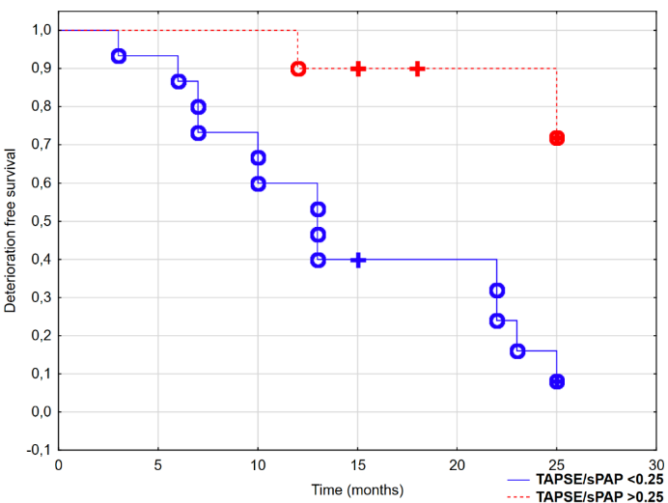
The potential predictive value of mechanical dysynchrony index and global longitudinal strain in patients with nonischemic cardiomyopathy and MRI confirmed active or previous myocarditis
Authors: Jan Kłyś, Joanna Boidol, Monika Kozieł, Karol Miszalski-Jamka, Zbigniew Kalarus, Tomasz Kukulski
Medical University of Silesia, Katowice, Poland

Rationale: The clinical course and ventricular remodeling in inflammatory myocardial disease could be unpredictable. Moreover ,no single functional parameter has been prooven as a powerfull predictor of VF/VT. The timing and indication for ICD implantation in nonischemic cardiomyopathy remains controversial.
Aim of the study: The aim of the study was to describe mechanical properties of the myocardium in patients with active or previous myocarditis.
Methods: Fifty consecutive pts (9F,41M) with nonischemic cardiomyopathy ( EDV-211±62ml, ESV129±71ml, EF42±16 %) and suspected inflammatory etiology were retrospectively analyzed. Acute or previous myocarditis was proved based on MRI assessment with standardized protocol dedicated to myocarditis and negative coronary angiography. Based on MRI calculated LVEF patients were divided into gr A( EF=<35% n=20) and gr B (EF>35% n=30) .For both groups LV global longitudinal strain (GLS) as well as mechanical dyssynchrony index (MDI) was calculated as a SD of time to peak longitudinal strain derived from all LV segments in 3 apical views.
Results: The mean follow up was 1,2 year , with 100% survival in both groups. In gr A 8/20 pts were protected using ICD (2pts as secondary prevention), and 2/30 in gr B (all secondary prevention). ICD. In group A 2 patients had VT/VF and in group B 2 patients had also VT/VF. Despite of similar QRS duration in both groups (107±13 ms vs 99±8 ms , p=0.057), LV MDI as well LV GLS were significantly higher in gr A than in gr B (68±19ms vs 41±15ms,p<0,001 and 8±2% vs 17±4% ,p<0,001 respectively). An overall correlation between MDI and QRS duration was poor (R=0,28) however it was fairly good (R=0,37) in GR A(EF<35%) and very week(R=0,16)in group B(EF>35%) (figure1). Similarly GLS as measured by echo correlated with MRI EF very well (R=0,69)in gr A and poorly in Gr B(R=0,17) (figure 1).
Conclusions: Mechanical dyssynchrony index and global longitudinal strain may serve as an additional markers in predicting outcome in nonischemic cardiomyopathy of inflammatory origin.
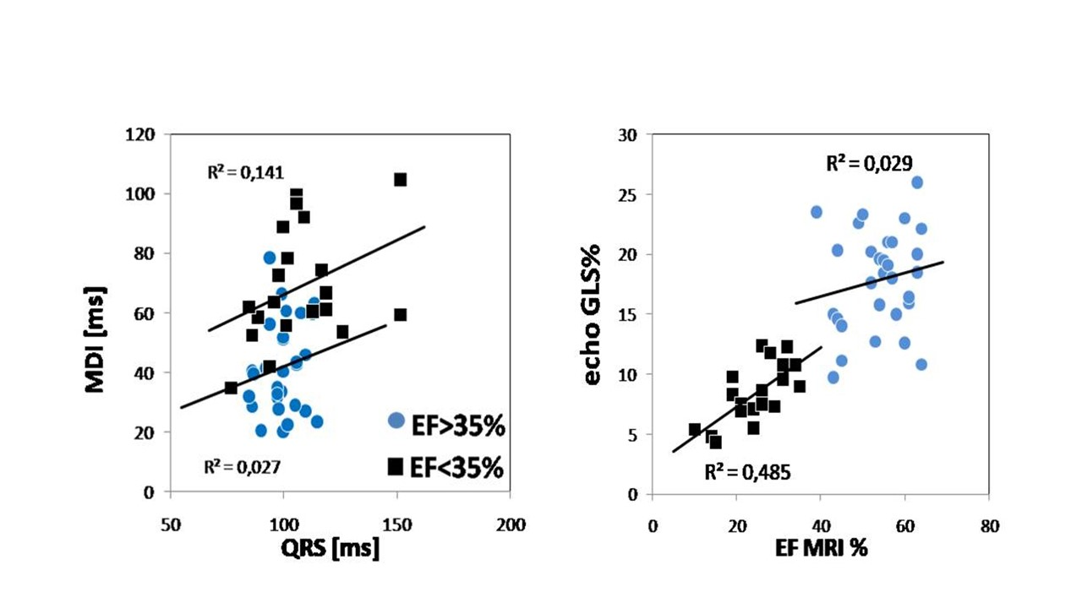
Automated assessment of left ventricular ejection fracion- new capabilities of hand-held ultrasonographic devices
Authors: Dominika Filipiak-Strzecka, Jarosław Kasprzak, Piotr Lipiec
Medical University of Lodz, Lodz, Poland
Background: Left ventricular systolic function evaluation is an essential part of all transthoracic echocardiographic examinations with the inclusion of the bedside assessment. Previously introduced handheld ultrasonography devices were limited to only visual left ventricular ejection fraction (LVEF) assessment. Such analysis can be described as easy, prompt, but operator- dependent. Due to the fact that hand-held ultrasonographic devices (HUD) are becoming more commonly acknowledged in the group of medical professionals other than echocardiographers the additional modality of automated measurements can possibly improve the diagnostic reliability of echocardiographic examinations when performed by non-expert sonographists.
Purpose: To validate Vscan LVivo application in automated measurement of the left ventricular ejection fraction (LVEF).
Methods: 50 cardiology ward patients (28 men, mean age 53± 6), who were referred for the conventional echocardiographic examination, underwent additional assessment performed with HUD. In each case 4 – chamber apical view was obtained and LVEF was calculated by means of the LVivo software. Imaging quality was assessed in a 4-grade scale. Subsequently, during the examination performed by means of the stationary echocardiograph reference 3D measurement of LVEF was recorded.
Results: Imaging quality was assessed as optimal, good, acceptable and poor in 13, 18, 13, 6 cases respectively. In 12 patients (26%, 2 good, 4 acceptable, 6 poor imaging quality) VScan was unable to calculate the automated LVEF value. In the remaining cases no statistically significant difference between the accuracy of the HUD and stationary device measurements could be detected (p=0,599, z=526). In patients in which the imaging quality could be described as either optimal or good p equalled 0,325 and z=0,985.
Conclusion: The LVivo software despite its limitations is capable of the accurate LVEF assessment when its calculations are based on the projections of at least good imaging quality. Such expanded capabilities of HUDs can potentially lead to the overall improvements of the diagnostic quality of ultrasonographic examinations, particularly when in hands of the non-echocardiographist.

Echocardiographic monitoring of exercise stress test using probe fixation device – very first human experience
Authors: Katarzyna Wdowiak-Okrojek, Zbigniew Bednarkiewicz, Konrad Wąsikowski, Piotr Lipiec, Jarosław Kasprzak
Medical University of Lodz, Lodz, Poland

Background: Stress echocardiography (SE) plays an important role among methods of noninvasive diagnosis of ischemic disease. Despite the advantages of physical exercise as the most physiologic stressor, it is difficult (bicycle ergometer) or impossible (treadmill) to obtain and maintain the acoustic window during the exercise. Recently, an innovative probe fixation device was introduced and a research plan was developed to assess the feasibility of external probe fixation during exercise echocardiography on a supine bicycle and upright treadmill exercise for the first time.
Methods: 37 subjects (36 men, mean age 39±16 years, 21 healthy volunteers, 16 patients with suspected coronary artery disease) were included in this study. This preliminary testing stage included mostly men due to more problematic probe fixation in women. All subjects underwent a submaximal exercise stress test on a treadmill (17/37) or bicycle ergometer (11/37). Both sector and matrix probes were used. We assessed semi-quantitatively the quality of acquired apical views at each stage – the four-point grading system was used (0-no view, 1-suboptimal quality, 2-optimal quality, 3-very good quality), 2-3 sufficient for diagnosis.
Results: The mean time required for careful positioning of the probe and image optimization was 12±3 min and shortened from 13,7 to 11,1 minutes (mean) in first vs second half of the cohort documenting learning curve. At baseline, 9 patients had at least one apical view of quality precluding reliable analysis. Those patients were excluded from further assessment. During stress, 17 patients maintained the optimal or very good quality of all apical views, whereas in 11 patients the quality significantly decreased during the stress test and required probe repositioning. The mean image quality score at baseline was 2,61±0,48 and 2,25±0,6 after exercise. Expectedly, good image quality was easier to obtain and maintain in the supine position (score 2,74±0,44) points as compared with upright position (score 2,25±0,57).
Conclusion: This preliminary, unique experience with external probe fixation device indicates that continuous acquisition and monitoring of echocardiographic images is feasible during physical exercise, and for the first time ever - also on the treadmill. This feasibility data stem from almost exclusively male patients and the estimated rate of sufficient image quality throughout the entire test is currently around 60%. We are hoping, that gaining more experience with the product could increase the success rate on exercise tests.

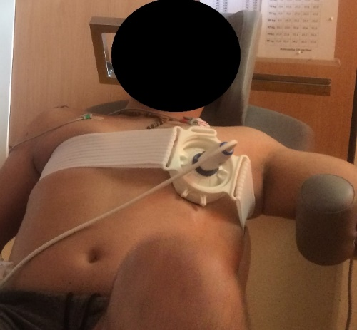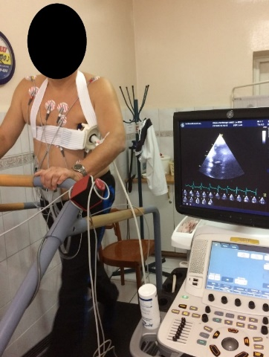

Comparison of global longitudinal strain and mechanical dyssynchrony of the left ventricle during right ventricular pacing and intrinsic conduction in patients with permanent pacemaker
Authors: Katarzyna Głuchowska, Rafał Dankowski, Artur Baszko, Stefan Ożegowski, Andrzej Szyszka
Poznan University of Medical Sciences, Poznan, Poland

Background. It has been shown that the right ventricular (RV) apical pacing may have detrimental effects on left ventricular function in patients with dual chamber pacemaker (PM). As a consequence, alternative sites of RV pacing have been proposed. However, little is known about the left ventricular function in patients (pts) with preserved atrioventricular (AV) conduction and alternative sites of RV pacing. Left ventricular (LV) global longitudinal strain (GLS) is a sensitive marker of the impairment of LV function. LV mechanical dyssynchrony (MD), calculated by measuring the standard deviation of the mean peak systolic strain of various LV segments, could be a valuable tool in the assessment of pacing effects form different sites in the RV.
The study aimed to compare GLS and MD in pts with implanted PM during intrinsic AV conduction and pacing form the right ventricular output tract (RVOT) or the right ventricular septum (RVMS)
Material and methods. The study included 42 patients (12 men; 28.6%, and 30 women; 71.4%) at 72±12 years of age who had previously received a PM. The indications for the PM implantation were: sick sinus syndrome (36 patients; 85,7%), atrioventricular block (5 patients; 11,9%), and one patient was diagnosed with both sick sinus syndrome and atrioventricular block (2,4%). All pts had preserved left ventricular ejection fraction (LVEF) without the history of previous myocardial infarction, regional wall motion abnormalities, persistent arrhythmias, bundle branch block, or clinically significant valvular heart diseases. Pacing-dependent patients without any intrinsic AV conduction have been excluded from the study. 28 (66,7%) pts had RVOT pacing 11 (26,2%) pts had RVMS pacing and 3 (7,1%) pts apical right ventricular pacing (RVA). GLS and MD were measured by 2-dimensional strain echocardiography during intrinsic sinus rhythm and after 5 minutes of 75 beat per minute ventricular pacing with constant atrioventricular delay 140 ms.
Results. There were no differences in LVEF values during intrinsic AV conduction and RV stimulation (63±4% vs 62±6%, p=0,33), however, left ventricular outflow tract velocity-time integral (VTI) was significantly lower during pacing (24,7±4,2 cm vs. 23,0±4,0 cm, p=0,003). For the whole group, GLS values during pacing were significantly reduced in comparison to GLS during intrinsic AV conduction (-20.4±2.7% vs. -22.2±2,4%, p<0,001). As expected, MD was significantly higher during pacing (43.8±15,4 ms vs. 39,7±14,3 ms, p=0,03). There were no differences in MD according to the pacing site (RVOT vs. RVMS: 37,3±11,1 ms vs. 40,3±15,8 ms, p=0,56). GLS values were significantly decreased in pts with RVMS pacing in comparison to RVOT pacing, both during stimulation (-19.6±2.3 vs -22,2±2,8%, p=0,005) and during intrinsic AV conduction (-21.6±2.1 vs -23,9±2,4%, p=0,005).
Conclusions. In patients with preserved atrioventricular AV conduction GLS values during stimulation are decreased. RVOT pacing, in comparison to RWMS pacing, is associated with better GLS pattern, even in the absence of differences in mechanical dyssynchrony.

Ultrasonic endothelial function for monitoring effects of chelation therapy
Authors: Shoa-Lin Lin, Wei-Chun Huang, Hsien-Wen Kuo
University at Albany, The State University of New York, New York

Introduction: The brachial artery flow-mediated dilation (FMD) using a non-invasive ultrasound method has been used to study endothelial function. Previous reports have claimed that impairment of the FMD may predict cardiovascular events, while preserved endothelial function is associated with favorable cardiovascular outcome. Chelation therapy may decrease the amount of heavy metals in the body, thus decrease the side effects of these toxic materials in affecting our health. However, the report of the impact of chelation therapy to the ultrasonic endothelial function in patients with elevated heavy metal levels was limited.
Methods and Results: Thirty coronary artery disease patients with elevated lead or cadmium level underwent antioxidant and ethylenediamine tetraacetic acid chelation therapy (EDTA) for more than 6 months were studied. The blood and urine lead and cadmium levels and ultrasonic endothelial function were evaluated. Lead and cadmium levels in blood and urine were reduced significantly after 3- and 6-month of chelation therapy (p<0.001). Ultrasonic endothelial function analysis also showed a progressive increase in the flow increase during reactive hyperemia (FIRH) and FMD after 3- and 6-month of treatments (p<0.05 compared with baseline data).
Conclusion: This study revealed that chelation therapy had a significant increase in the ultrasonic parameters of FIRH and FMD, which suggest that this therapy may have favorable impacts in the ultrasound endothelial function in patients with elevated heavy metals.

New predictors of burned-out phase in hypertrophic cardiomyopathy
Authors: Daria Adamczak, Jacek Migaj, Joanna Zielińska, Peter Szafaryn, Zofia Oko-Sarnowska
Poznan University of Medical Sciences, Poznan, Poland

Background: Hypertrophic cardiomyopathy (HCM) is a heart disease characterized by hypertrophy of the left ventricular myocardium. The structural and functional abnormalities cannot be explained by flow-limiting coronary artery disease or loading conditions. HCM has a benign course, however, approximately 5% of these patients suffer from the end-stage of the disease. The so-called burned-out phase, characterized by systolic dysfunction with a left ventricular ejection fraction ≤50%, is often associated with wall thinning and chamber dilation. These patients should have more frequent clinic visits and have a more intensive treatment plan. They are also candidates for heart transplantation. Currently, there are no risk factors of progression to burned-out phase before the onset of heart failure symptoms. Therefore, the potential risk factors: left ventricular global longitudinal strain (GLS), left ventricular average strain (ASI), right ventricular average strain (RV-ASI) and left atrial volume index (LAVI), have been examined. GLS, derived from speckle tracking echocardiography, and ASI, derived from tissue doppler imaging, are the sensitive and noninvasive methods of assessing the ventricular function. LAVI more accurately characterizes the size of the left atrium, which usually increases in the course of the disease.
Methods: A total of 252 patients with HCM (aged 20-88 years, 49,6% were men), treated in 1st Department of Cardiology, Poznan University of Medical Sciences, Poland, have been enrolled in the study. GLS, ASI, RV-ASI and LAVI assessment has been made in addition to standard echocardiographic examination (Vivid-E9). Burned-out was characterized as systolic dysfunction with a left ventricular ejection fraction ≤50%. The statistical analysis was performed with Statistica 13, StatSoft, Tibco Software Inc.
Results: 5.6% of patients in the study population were in the burned-out phase of the disease. The t-Student test and t-Student test with Cochran-Cox adjustment showed statistically significant differences of GLS and ASI values between burned-out and non-burned-out groups; p=0.000001 and p<0.000001, respectively. Average and median values of GLS in burned-out group were -7.4% ± 2.9%, -7.1% and -15.3% ± 4.3%, -15.4% in non-burned-out group. For ASI those values were respectively -7.6% ± 2.2%, -7.1% and -12.9% ± 4.5%, -13.0%.
The Mann-Whitney test showed statistically significant differences of RV-ASI and LAVI values between burned-out and non-burned-out groups; p=0.000208 and p=0.005302, respectively. The median value of RV-ASI in burned-out group was -15.8% and -27.1% in non-burned-out group. The median value of LAVI in burned-out group was 52.6 ml/m2 and 37.8 ml/m2 in non-burned-out group.
Conclusions: Each of the proposed new risk factors of burned-out development was statistically significant in the study population. Therefore, all HCM patients should have regular echocardiographic examinations and those with deteriorating values of new parameters should become the subjects of intensified medical care.
Figure 1. The values of GLS in patients with and without progression to the burned-out phase of HCM.
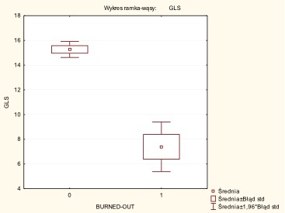

Comparison of clinical and echocardiographic parameters between younger (≤ 60 years) and older (> 60 older) heart failure patients treated with sacubitril+walsartan
Authors: Sylwia Wiśniowska-Śmiałek, Aleksandra Karabinowska, Katarzyna Holcman, Ewa Dziewięcka, Agata Leśniak- Sobelga, Marta Hlawaty, Magdalena Kostkiewicz, Piotr Podolec, Paweł Rubiś
Jagiellonian University Medical College, Krakow, Poland

Background: Along with the increasing number of heart failure patients with reduced ejection fraction (HFrEF) optimal pharmacotherapy including new class ARNI with sacubitryl-valsartan are crucial for the extending the time between hospitalizations and improvement of the quality of life. Methods: Since July 2016 till February 2019 we started ARNI in 50 HFrEF patients: 24 (48%) were < 60 years old and 26 (52%) were older than 60. Results: There were significant differences in age and the duration of the disease between groups. There were no differences observed between most of the echocardiographic parameters including left ventricular end- diastolic and end-systolic diameter (LVEDd, LVESd), volume (LVEDvol, LVESvol), ejection fraction (EF) and left and right area (LAA and RAA). Systolic function of right ventricle presented with tricuspid annular plane systolic excursion ( TAPSE) were similar between groups but older patients had greater value of estimated systolic pulmonary pressure (PASP). Both groups significantly decreased NYHA class during 3 months of ARNI therapy ( < 60 y.o: 2,6±0,8 vs 1,5±0,6, p= 0,00; > 60 y.o: 2,6±0,6 vs 1,95±0,4, p= 0,002) and older patients improved distance in 6 minute walking test ( 348m (240-380) vs 428m (390-430), p=0,04). Conclusions: Despite pronounced differences in age and the duration of the disease between groups both took the advantages from the optimal HFrEF pharmacotherapy including sacubitryl + walsartan.

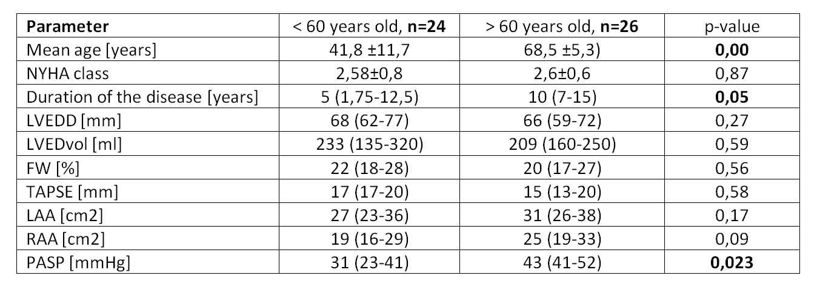

Hemodynamic profile differences of stenotic bicuspid and tricuspid aortic valve – data from
Authors: Aneta Stróżyk, Maria Nowak, Dominika Dworakowska, Alicja Bielachowicz, Wiktoria Szram, Tobiasz Sławiński, Michalina Osowicka, Marcin Fijałkowski
Medical University of Gdansk, Gdansk, Poland

Background: Aortic stenosis is the most common primary valve disease leading to surgery or catheter intervention with a growing prevalence due to the ageing population. Echocardiography is the key diagnostic tool and assessing the severity of aortic stenosis based on Doppler parameters. Thresholds of stenosis severity are the same for tricuspid and bicuspid aortic valve (BAV) although the population with BAV is different. The aim of this study was to evaluate the hemodynamic profile of patients with stenotic bicuspid aortic valve.
Methods: Data was obtained from aortic stenosis registry (ASRegistry). Patients enrolled to Registry were hospitalized from 2012 to 2018 in 1st Department of Cardiology, Clinical Centre of Cardiology, Medical University of Gdańsk. All patients underwent echocardiographic examination with Doppler parameters and BAV was evaluated visually.
Results: 621 patients (328 females, 293 males) had sever aortic stenosis with aortic valve area (AVA) < 1cm2. There were 72 (11,6%) patients with bicuspid aortic valve in study group. The peak transvalvular velocity (Vmax) was significantly higher in BAV group: 4,5±7,2 m/s vs 4,1±7,7 m/s, p<0,0001; also mean transvalvular pressure gradient (PGmean) was higher in the patients with BAV: 52±19 mmHg vs 42±16,2 mmHg, p<0,0001. The average age at diagnosis was significantly lower in BAV patients group: 62 ±12 vs 77±9,5; p<0,0001. The left ventricle ejection fraction (LVEF) was higher in BAV patients group: 58±13% vs 55±31%; p<0,0001.
Conclusions: The values of echocardiographic Doppler parameters in BAV severe aortic stenosis are different than in tricuspid aortic valve that can suggest revision of Doppler aortic valve severity threshold for those entities.

What is new in echocardiography assessment of patients with hereditary hemochromatosis – is 2D speckle tracking analyzes helpful in early detection of heart abnormalities?
Authors: Ludmiła Daniłowicz-Szymanowicz, Małgorzata Szwoch, Katarzyna Rozwadowska, Katarzyna Sikorska, Marcin Fijałkowski, Marcin Gruchała, Grzegorz Raczak
Medical University of Gdansk, Gdansk, Poland

Background: Hereditary hemochromatosis (HH) is a very common inherited disease. Abnormally increased intestinal iron absorption and accelerated recycling of iron by macrophages lead to progressive body iron accumulation and the generation of oxidative stress in tissues. In the late stages iron overload of the heart can lead to the left ventricular (LV) dysfunction. It is believed that two dimensional speckle tracking echocardiography (2D STE) can evaluate LV dysfunction more accurately and earlier than conventional echocardiography. This seems to be clinically important before a substantial damage of the heart. Evaluation of such assessment was the purpose of this paper. Methods: We prospectively included 58 patients with genetically confirmed HH (from 1 to 250 months from diagnosis); 29 healthy age- and sex-matched volunteers constituted the control group. Classic echocardiographic as well as 2D STE parameters (longitudinal strain, rotation and twist parameters) were assessed and compared between the groups (GE VIVID E9 ultrasound system, EchoPAC workstation (v201)- GE Healthcare Horten, Norway). Results. The HH patients had all standard echo parameters within normal range, however the parameters regarding diastolic function and LV ejection fraction were worse than in controls. All 2D STE parameters were significantly worse in HH patients in comparison to control group (Table 1). We did not find significant linear correlations between echo and iron turnover parameters, but there were significant correlations with the time from diagnosis and the numbers of venesections in HH patients.
HH
n=58 Controls
n=29 p
Age 47 (31 – 57) 47 (38 - 60) 0.371
Sex (males) 38 (65.5%) 13 (45%) 0.105
Left atrium volume index (ml/BSA) 31 (23 – 36.5) 21.5 (19 – 27.1) < 0.001
Relative wall thickness 0.42 (0.38 – 0.47) 0.38 (0.34 – 0.43) < 0.003
LV mass index (g/BSA) 78 (58 - 96) 66 (53.3 - 72) < 0.006
E/Em 7 (5.6 – 8.3) 6.7 (5 – 7.5) 0.071
LV ejection fraction (%) 60 (54 - 62) 63 (61 – 64.5) < 0.006
LV global twist (º) 17.2 (13.1 – 22.2) 24.1 (19.9 – 32.1) < 0.001
LV torsion (º/cm) 0.22 (0.16 – 0.29) 0.33 (0.27 – 0.43) < 0.001
LV peak rotation velocity (º/s) 118 (88.3 – 146.3) 140 (112.7 – 168.9) < 0.015
LV peak untwisting velocity (º/s) -132 (-163.5 – -93) -156 (-197 – -122.6) < 0.039
Peak systolic longitudinal strain (%) -18.3 (-20 – -16.9) -21 (-22 – -19.3) <0.001
Conclusions: Novel echocardiographic methods (such as 2D STE) seems to be helpful in early detection of heart abnormalities in HH patients. The correlations between the echo parameters and iron indices in the serum are weak, what allows to suggest that there is the absence of a “direct” relationship between the levels of iron turnover parameters and myocardial function and that myocardial iron overload is not the only mechanism involved in the development of HH cardiomyopathy.

 | HH  n=58 | Controls  n=29 | p
Age | 47 (31 – 57) | 47 (38 - 60) | 0.371
Sex (males) | 38 (65.5%) | 13 (45%) | 0.105
Left atrium volume index (ml/BSA) | 31 (23 – 36.5) | 21.5 (19 – 27.1) | < 0.001
Relative wall thickness | 0.42 (0.38 – 0.47) | 0.38 (0.34 – 0.43) | < 0.003
LV mass index (g/BSA) | 78 (58 - 96) | 66 (53.3 - 72) | < 0.006
E/Em | 7 (5.6 – 8.3) | 6.7 (5 – 7.5) | 0.071
LV ejection fraction (%) | 60 (54 - 62) | 63 (61 – 64.5) | < 0.006
LV global twist (º) | 17.2 (13.1 – 22.2) | 24.1 (19.9 – 32.1) | < 0.001
LV torsion (º/cm) | 0.22 (0.16 – 0.29) | 0.33 (0.27 – 0.43) | < 0.001
LV peak rotation velocity (º/s) | 118 (88.3 – 146.3) | 140 (112.7 – 168.9) | < 0.015
LV peak untwisting velocity (º/s) | -132 (-163.5 – -93) | -156 (-197 – -122.6) | < 0.039
Peak systolic longitudinal strain (%) | -18.3 (-20 – -16.9) | -21 (-22 – -19.3) | <0.001

Left ventricular ejection fraction and left atrial size are associated with the risk of thrombus in the left atrial appendage in patients with atrial fibrillation
Authors: Beata Uziębło-Życzkowska, Paweł Krzesiński, Agnieszka Jurek, Agnieszka Kapłon- -Cieślicka, Iwona Gorczyca, Monika Budnik, Grzegorz Gielerak, Marek Kiliszek, Monika Gawałko, Piotr Scisło, Janusz Kochanowski, Olga Jelonek, Anna Michalska, Katarzyna Starzyk, Krzysztof J. Filipiak, Beata Wożakowska-Kapłon, Grzegorz Opolski
Military Institute of Medicine in Warsaw, Warsaw, Poland

Background: Atrial fibrillation (AF) is associated with high risk of ischemic stroke. The most frequent thrombus location in AF is the left atrial appendage (LAA). However, the risk factors for LAA thrombus (LAAT) formation are still investigated. Transthoracic echocardiography (TTE) is a basic diagnostic examination in patients (pts) with AF.
Purpose: To analyse the relations between basic echocardiographic features, well established stroke risk factors (included in CHA2DS2-VASc score), type of AF and anticoagulation therapy with the incidence of LAAT.
Methods: The study group consisted of 768 pts with AF (mean age 63 years (y); 62% men; 37% paroxysmal AF), admitted to 3 Polish high-reference cardiology departments between 2014 and 2017. 523 pts (68%) were treated with non-vitamin K antagonist oral anticoagulants (NOACs), 227 (30%) with vitamin K antagonists (VKAs). The subjects underwent TTE and transesophageal echocardiography (TEE) before cardioversion or ablation.
Results: LAAT was significantly more frequent in pts with reduced LVEF: in 10.6% (7 pts) with LVEF <40%, in 9.0% (9 pts) with LVEF 40-49%, while only in 5.5% (33 pts) with LVEF>50%. Compared to pts without LAAT, those with LAAT presented with: lower LVEF (49.5±12.1 vs 54.8±9.9%; p<0.0001) and higher left atrial diameter (LAD) (4.77±0.59 vs 4.47±0.55 cm; p=0.009). Multivariate logistic regression revealed the following variables as independent predictors of LAAT: bleeding in anamnesis, treatment with VKA and LVEF – Table.
Conclusion: LAAT is related to lower LVEF and higher LAD. LVEF is one of the independent predictors of LAAT. Even in case of adequate anticoagulant therapy it might be prudent to consider TEE before cardioversion or ablation in patients with low LVEF and LA enlargement, especially in the coexistence of other thromboembolic risk factors.

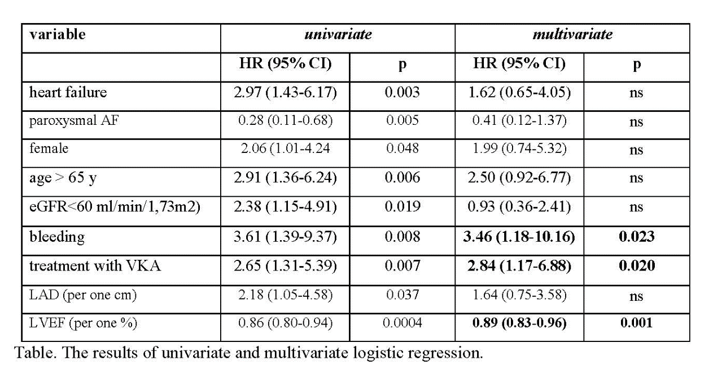
Pregnancy in patients after Fontan procedure – single center experience
Authors: Agnieszka Bartczak-Rutkowska, Olga Trojnarska, Aleksandra Ciepłucha, Maciej Lesiak
Poznan University of Medical Sciences, Poznan, Poland

Fontan procedure enabled patients with complex congenital heart defects unsuitable for biventricular repair reach adulthood. This unique surgical technique led to increased number of women in childbearing age who desire to have children. Despite improved survival patients after Fontan palliation are vulnerable to wide spectrum of complications, including arrhythmia, single ventricular dysfunction and thromboembolic events. Also pregnancy as prothrombotic and hiperdynamic state is challenging for distorted cardiac anatomy and physiology of univenricular hearts.
The aim of our study was to assess maternal and fetal outcome in patients after Fontan procedure.
Results: Four women with single ventricle physiology underwent nine pregnancies (at median age 22 years). There were four miscarriages at median 9,5th week of pregnancy. Five pregnancies resulted in the delivery at median 37th gestational week.
Detailed description: One woman with double inlet left ventricle after classic Fontan surgery (right atrium connected to pulmonary artery) had five pregnancies, which resulted in two healthy newborns. Her first pregnancy at the age of 17 was delivered in 37th week by cesarean section (cs), subsequent 3 pregnancies ended as miscarriages in 8th, 11th and 18th gestational week due to supraventricular arrhythmia (atrial fibrillation) and fifth pregnancy occurred at the age of 24 and was delivered in 36th week by urgent cs due to placenta abruption, healthy newborn was born. Unfortunately this patient died five years later. Second patient with tricuspid atresia after Fontan surgery (total cavo-pulmonary connection, TCPC) had two pregnancies- one resulted in spontaneous miscarriage in 5th week, the other was successful and in 36th week at the age of 26 years newborn with spina bifida was delivered. Third patient with double inlet left ventricle after TCPC had one pregnancy and at the age of 22 in the 37th week delivered a healthy newborn. Fourth woman with double outlet right ventricle after TCPC underwent one pregnancy at the age of 28 years which resulted in cs in the 38th week, healthy newborn was born.
Conclusions: The number of pregnancies in women after Fontan procedure will be increasing. To adequetly manage these patients thorough knowledge of anatomy, physiology and performed cardiac surgeries is required. In our group no maternal death was observed. The only complication was supraventricular arrhythmia without ventricular dysfunction. This study proves that pregnancy and delivery are achievable in this population. However one should consider still shortened survival in this group and arising problem of upbringing these children.
ABS-WCE-119 (2019-03-24 16:03:20)
Chest pain - is it always what it seems to be? Case report
case report
A 56-year-old patient, after aortic aneurysm dissection surgery in emergency mode (31.03.2017: replacement of ascending aorta and arch, with aortic arch arteries transplantation and aortic valve repair), after common iliac artery operation due to acute ischemia of the right lower limb (dissection included abdominal aorta, iliac arteries), with a 70% distal stenosis in LAD in angio CT, qualified as insignificant (previously), with well-controlled arterial hypertension, hemodynamically stable, with weekly history of permanent chest pain radiating to the inter-scapular area and the left shoulder, not connected with physical exertion, without dyspnea. In subsequent ECGs: regular sinus rhythm, q III dependent on respiratory, nonspecific STT changes I, aVL to -0.5mm, V4-V6 to -1mm, without evolution. TnThs 11ng/L, CK-MB mass 1.36ng/ml. After NTG iv. only reduction of the symptoms. Angio CT changes in aorta compared to the study from 17.10.2017: prosthesis without leak, aortic arch arteries not dissected, chronic dissection of the wall from the level of the descending aorta to bifurcation to the iliac arteries. In angio CT of the coronary arteries: significant long stenosis of LAD. No indications for cardiac surgery. Due to the unclear cause of the symptoms, untreated changes in LAD, until now without coronary angiography, the patient was qualified for hospitalization to diagnose the cause of pain in the chest. Transthoracic echocardiography did not reveal segmental changes in ventricular wall contractility, showed normal left ventricular systolic function (LVEF 65%), trace of IA and a good distant effect of aortic valve repair surgery. Currently, no data for pulmonary embolism. ACS-UA was diagnosed. In coronary angiography in the LAD long 80% stenosis - an isolated change. Aortography confirmed the good effect of prosthesis operation of the ascending aorta. Simultaneously, PCI of LAD, segm. 7/IDg (bifurcation) with DES implantation (sirolimus) was performed - with a PCI-LAD result: 80% -0%, TIMI flow 3. The symptoms disappeared. Unusual chest pains in a patient with aortic aneurysm, even after successful surgery, may correspond to ACS, being an indication for coronary angiography / angioplasty of coronary arteries, after exclusion of the causes of the main artery. The key to the right treatment decisions is quick differential diagnosis (also by imaging techniques!) of pain, which is not always what it seems to be.
The literature describes numerous cases of patients in whom the initial suspicion of ACS was finally verified, stating that the cause of the symptoms is acute aortic syndrome, eg. aortic dissection. The distinction between these two disease entities is important, as it is necessary for the administration of anticoagulation in ACS, which is from the opposite side, contraindicated and exacerbates the course of aortic dissection. There are no papers highlighting the importance of differential diagnosis in the reverse direction, although this issue is also important, because the delay in performing coronarography / coronaroplasty and the implementation of antiplatelet therapy in ACS reduces the chances of effective treatment of this disease.

Natriuretic peptides response to exercise and transthoracic echocardiography findings in patients diagnosed for coronary disease
Authors: Dariusz Sławek, Anna Bińkowska, Jarosław Damian Kasprzak
Medical University of Lodz, Lodz, Poland

Purpose: We attempted to determine echocardiography results depending on the results of NT-proBNP concentrations as potential marker indicating angiographic stable coronary artery disease (SCAD) defined as ≥50% reduction in diameter of at least one large coronary artery segment.
Methods: We included 100 patients (pts, 23% women), diagnosed with chest pain and qualified for elective coronary angiography. The protocol included medical examination, ECG exercise test (EET), assessment of biochemical markers, transthoracic echocardiography (TTE). In addition measurement of the concentration of NT-proBNP at rest and 10 minutes after EET was performed to assess its variation during exercise .
Results: SCAD was found in 59% of pts. We found a higher mean pre- and postexercise concentrations of NT-proBNP in SCAD (+) group respectively – 147,4 pg/ml vs 95,2 pg/ml in SCAD (-), p= 0,004, and 168,0 pg/ml vs 97,6 pg/ml p= 0,007. We observed a moderate trend in the increase of the concentrations of NT-proBNP (ΔNT-proBNP) after exercise in a SCAD (+) group, compared to SCAD (-) group: 8,5 pg/ml vs 6,2 pg/ml, p= 0,07. Patients with SCAD had a significantly lower ejection fraction (EF): 53,6% vs 57,0% p= 0,009, greater left ventricular (LV) mass: 266,5 g vs 234,9 g, p=0,007, larger LV diameters, diastolic: 48,8 mm vs 46,7 mm, p= 0,036 and systolic: 34,2 mm vs 32,3 mm, p= 0,057. We found a significant positive correlation between NT-proBNP concentration before and after EET and LV mass: ρ= 0,24 p= 0,017, ρ= 0,24 p= 0,019, LV mass index: ρ= 0,287 p= 0,0044, ρ= 0,288, p= 0,0045, end diastolic: ρ= 0,24 p= 0,017, ρ= 0,23 p= 0,025 and systolic dimensions of LV: ρ= 0,25 p= 0,014, ρ= 0,23 p= 0,021 and with wall motion score index - ρ= 0,257 p= 0,01 and ρ= 0,263 p= 0,008. We observed similar negative correlations between NT-proBNP concentrations and EF as well as before, and after EET, respectively: ρ= -0,22 p= 0,023, ρ= -0,22 p= 0,027. In the subgroup of patients with preserved LVEF≥55% and SCAD, significantly higher NT-proBNP concentrations were observed, both before and after EET as compared to patients with preserved LVEF and without SCAD, respectively: 147,4 pg/ml vs 79,5 pg/ml, p=0,008 and 168,0 pg/ml vs 80,7 pg/ml, p=0,015, but the exercise change of ΔNT-proBNP was similar in the both subgroups: 7,6 pg/ml vs 6,6 pg/ml, p= 0,128. Similar relationships were found among patients without any LV contractility abnormalities detected in TTE, respectively: 139,5 pg/ml vs 94,0 pg/ml, p= 0,034, 154,3 pg/ml vs 93,7 pg/ml, p= 0,061 and in respect to ΔNT-proBNP: 13,7 pg/ml vs 6,7 pg/ml, p= 0,15.
Conclusions: Concentrations of NT-proBNP before and after EET are higher in patients with SCAD but degree of exercise change is similar. Evaluation of NT-proBNP concentration may be used as additional factor indicating to improve accuracy of non-invasive diagnosis of CAD.

The influence of acromegaly treatment on subclinical left ventricular dysfunction assessed by two-dimensional speckle tracking echocardiography (2D-STE)-preliminary study
Authors: Agata Popielarz-Grygalewicz, Maria Stelmachowska-Banaś, Jakub Sławomir Gąsiort, Magdalena Czubalska, Katarzyna Rakowska, Wojciech Zgliczyński, Wacław Kochman
Medical University of Warsaw, Warsaw, Poland

Introduction: Cardiac disease called acromegalic cardiomyopathy may be present in patients with acromegaly at diagnosis, however most echocardiographic studies showed that systolic function measured by ejection fraction (EF), in these patients is normal. Speckle tracking echocardiography (STE) is a novel method that allows for the study of global longitudinal strain (GLS), a marker of early and subclinical left ventricular (LV) systolic dysfunction.
Objective: To assess the effect of acromegaly treatment on left ventricular GLS in patients with normal EF.
Patients and methods: Twenty consecutive patients (mean age 49±14 years) with naïve acromegaly admitted to our department in 2018 were enrolled in the prospective study. The patients were preoperatively treated with somatostatin analogs (lanreotide autogel and octrotide LAR) while awaiting for pituitary surgery. All patients with normal systolic LV function measured by ejection fraction (EF) underwent 2D-STE at baseline and after 3, 6 months of treatment with somatostatin analogs and 3 months after pituitary surgery.
Results: The median GH was increased at baseline [in ug/L, 5.06 (IQR: 0,6-69.3)] and decreased significantly after 3 and 6 months of somatostatin analog treatment and after surgery [in ug/L 1.29 (IQR: 0.05-34.9), 1.24 (IQR: 0.1-20.9), 0.31 (IQR: 0.05-4.92), p<0.05, respectively]. The mean IGF-1 level was increased at baseline (in xULN, 2.89±1.06) and decreased significantly after 3 and 6 months of somatostatin analog treatment and 3 months after surgery (in xULN, 1.54±0.92; 1.86±1.24; 1.47±0.86, p<0.05, respectively). The mean GLS in patients with acromegaly at baseline was below the normal range (in%, -18.74 ± 2.64) and increased 3, 6 months after somatostatin analog treatment and 3 months after surgery (in%, -19.38±2.76; -19.21±2.88; -20.88±1.75, respectively), although statistical significance (p<0.05) was reached only between GLS at baseline and GLS measured in patients 3 months after pituitary surgery. There was no statistical significant correlation between baseline GLS and GH or IGF-1 concentrations (p>0.05).
Conclusions: Untreated acromegalic patients presented with subclinical systolic dysfunction expressed by decreased GLS. Systolic LV function improves as an effect of acromegaly treatment, particularly after pituitary surgery along with the decrease of GH and IGF-1 concentrations. The effective medical and surgical treatment of acromegaly may be responsible for prevention of development of overt cardiac insufficiency in acromegalic patients in recent years.

Asymptomatic massess on endocardial leads in patients undergoing transvenous leads extraction
Authors: Anna Polewczyk, Dorota Nowosielecka, Andrzej Kleinrok, Andrzej Kutarski
Jan Kochanowski University in Kielce, Kielce, Poland

Background: Patients with cardiac implantable electronic devices sometimes present the asymptomatic massess on endocardial leads (AMELs). Clinical relevance of AMELs is not yet known.
Methods: We analyzed the clinical data of 167 patients (mean age 66,76 years; 63% male) undergoing transvenous leads extraction (TLE) procedures in single center due to noninfective indications in years 2018-2019.
Results: The presence of additional structures on the leads was found in 40.1% of patients. Detailed analysis revealed the most frequent occurrence of unspecified thickening (12%) and adhesions of the leads (12%). The next finds were: thrombi (4.8%) and fluttering fragments of connective tissue (4.8%). In 2,4% of patients, the unspecific, probably postinflammatory structures were observed. AMELS before TLE
Landscape before the battle Number of patients (%) 167 (100%)
Thickening of the lead 20 (12,0%)
Adhesions of the leads 20 (12,0%)
Thrombus 8 (4,8%)
Fragments of connective tissue 8 (4,8%)
Unspecific probably postinflammatory structures 4(2,4%)
Combinations of all above 25 (15%)
Conclusions: Asymptomatic additional structures are a common phenomenon, probably closely related to the intense growth of endocardial leads, as well as an inflammatory reaction on the foreign body with increased coagulation.
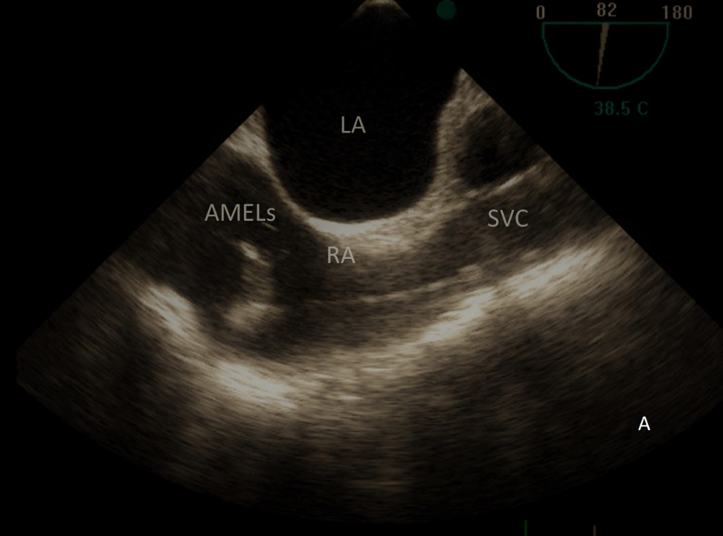

Impaired left ventricular systolic function in alcohol abusers expressed by both 3D calculated ejection fraction and longitudinal strain by AFI
Authors: Piotr Hamala, Jarosław Kasprzak, Piotr Lipiec, Karina Wierzbowska-Drabik
Medical University of Lodz, Lodz, Poland

Aim: Despite knowledge regarding the existence of alcohol cardiomyopathy the exact impact of alcohol abuse in consecutive subject is poorly examined.
We aimed to evaluate the left ventricle (LV) function in chronic abusers group and compared classical and novel echocardiography parameters in alcohol abusers (ALC) and control group (C).
Methods: We compared 75 adults (mean age 48±12, 60 male) without other overt heart disease, coronary artery disease excluded, but with alcohol abuse history: average alcohol intake 32 alcohol unit per week (AUW) with control group consisted of 40 subjects without history of excessive drinking, abstinents or drinking ≤8 AUW (mean age 50±4, 16 men). One unit was defined as 10 grams of pure etanol. All patients underwent TTE examination including ejection fraction (EF) calculation with 3D and longitudinal strain assessment by AFI.
Results: ALC group showed LV systolic dysfunction expressed as EF 48±14 vs 60±9%, global longitudinal strain (AFI GLS) -15.6±6.6 vs -18.7±3.4; p <0.0001 and p 0.0064, respectively. On the other hand the LV and left atrial diameters as well as diastolic function were similar in both groups, indicating on relatively low advancement of heart remodeling.
Conclusions: Chronic alcohol abuse revealed harmful effect on LV systolic function which can be assessed quantitatively by both decreased EF and absolute values of myocardial longitudinal strain. This systolic function impairment seems to anticipate the overt remodelling of the heart.

The role of transthoracic ultrasound in diagnostic algorithm in patient with heart failure with preserved (HFpEF) and mid-range ejection fraction (HFmrEF)
Authors: Anna Lisowska, Małgorzata Knapp, Izabela Płońska, Tomasz Olesiewicz, Bartosz Król, Emilia Sawicka, Marcin Jakub Kamiński, Bożena Sobkowicz
Medical University of Bialystok, Bialystok, Poland

Introduction: Transthoracic ultrasound is used in semi-quantitative estimation of lung hydration in patients with heart failure with reduced ejection fraction (HFrEF). The presence and summation of the number of B lines are symmetrically assessed on both sides of the chest. There is no data about possibility of using this diagnostic method in patients with heart failure with preserved (HFpEF) and mid-range ejection fraction (HFmrEF).
Methods: The analysis included 35 patients (mean age 74.6 years) hospitalized due to an exacerbation of heart failure: 18 (52%) HFpEF patients (EF≥50%) and 17 (48%) HFmrEF patients (EF=40-49%). In all patients NTproBNP was obtained and lung ultrasound was twice performed: on the 1st and 5th day of hospitalization.
Results: Clinical evaluation revealed: 16 (46%) patients in II NYHA class (NTproBNP concentration 946.5 ± 438 pg/mL) and 19 (52%) patients in III NYHA class (NTproBNP 3058.4 ± 1241.8 pg/mL). The average number of B lines in ultrasonography was 1.6±0.2 in HFpEF group, while 2.3±0.2 in HFmrEF patients. The number of lines significantly correlated with the NYHA class (p = 0.021, r = 0.44) and EF (p = 0.003, r = 0.43), while correlation with NTproBNP was not found. The B lines number was clinically significant at baseline (≥2 in the upper lung segment and ≥3 in the lower lung segment) in 33 patients (94%) as well as after treatment – 64 % (p=0.01).
Conclusion: The results confirm clinical significance of ultrasonography in lung fluid overload assessment in HFpEF and HFmrEF patients.

Lead dependent tricuspid dysfunction before and after transvenous lead extraction
Authors: Anna Polewczyk, Dorota Nowosielecka, Wojciech Jacheć, Andrzej Kleinrok, Andrzej Kutarski
Jan Kochanowski University in Kielce, Kielce, Poland

Background: Laed dependent tricuspid dysfunction (LDTD is an abnormality associated with the course of the lead through the tricuspid valve (TV).
Aim: Evaluation of clinical presentation of patients with LDTD and function of TV before and after transvenous leads extraction (TLE) with the assesment of long term survival after TLE
Methods: Analysis of echocardiographic examinations (TTE and TEE) of 488 patients undergoing TLE in single center in years 2016-2017 was conducted with isolation of 33 patients with LDTD. Clinical and procedural factors associated with LDTD were compared as well as the impact of the TLE procedure on TV function and mortality.
Results: The direct cause of LDTD in most cases (51.5%) was the presence of loop of the lead. Clinical presentation of LDTD group was worse than other patients ondergoing TLE: mean NYHA class: 2,18±0,64 vs 1,98±0,56; p0,05; PASP: 41,17±13,94 vs 29,29±14,38 ; p<0,001. In 35,7% of patients with LDTD the reduction of tricuspid regurgitation (TR) after TLE was achieved, the worsening of TR after procedurę was observed in 7,1% of patients. Overall effectiveness of TLE (full procedural success) in patients with LDTD was 97% with 3% of major complications and lack of periprocedural mortality. Long term survival pf patients with improvement of TV function after TLE was better than in cases without reduction of TR.
Conclusions: LDTD is a potentially dangerous abnormality affecting on the development of heart failure. A frequent cause of LDTD is loop of the lead. Transvenous leads extraction is the safe and often effectve method of the improvement of TV function with positive influence on long term survival of patients with LDTD.

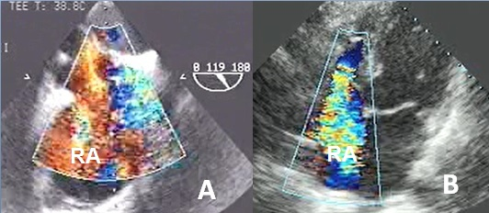

How to evaluate the significance of aortic regurgitation in asymptomatic patients?
Authors: Anna Borzyszkowska, Karolina Dorniak, Izabela Pisowodzka, Jadwiga Fijałkowska, Rafał Gałąska, Marcin Fijałkowski
Medical University of Gdansk, Gdansk, Poland

Background: Aortic regurgitation (AR) can be caused by primary disease of the aortic valve cusps and/or abnormalities of the aortic root and ascending aortic geometry. According to current guidelines, surgery is indicated in asymptomatic patients with left ventricle ejection fraction (LVEF) <50% - assessed by transthoracic echocardiography (TTE). Surgery should be considered in asymptomatic patients with resting ejection fraction >50% and severe LV dilatation: LVEDD >70 mm or LVESD >50 mm (or >25 mm/m2). In asymptomatic patients assessment of AR significance as well as choosing optimal time for surgery is challenging. In patients with severe AR and deteriorated LV function prognosis is already worsened and surgical intervention may not provide optimal outcomes. Cardiac magnetic resonance (CMR) is a promising tool to assess LV enlargement and volumes as well as regurgitant volume and fraction.
The aim of our study was to investigate possible volumetric and hemodynamic parameters of the significance of regurgitation among asymptomatic patients with severe AR assessed by echocardiography and CMR.
Methods: We identified 17 patients with AR. All patients underwent TTE, TOE and CMR within one month since admission to the hospital. Diameters and volumes of LV were assessed by TTE and CMR. One patient was excluded due to turbulent flow in ascending aorta and unreliable direct measurement of the regurgitant volume and fraction. Another patient was excluded due to insignificant AR confirmed by both methods. The majority of patients (14/15) were scanned on a 1,5 T scanner (Siemens Aera, Erlangen, Germany) and one patient on a 3 T scanner (Phillips Achieva, Best, The Netherlands). For TTE assessment GE Vivid E 95 was used. LV volumes were quantified with bi-plane Simpson method (TTE) and short axis cine stack covering the entire LV volume (CMR). The results were statistically analyzed with Student’s t-test and Pearson’s correlation test.
Results: We included 15 patients (all male), aged 51± 9 years. All patients had significant AR in TTE, LVEF > 50% and regurgitant fraction in CMR > 30%.
The respective TTE and CMR measurements (LVEF, diameters and volumes) were as follows: LVEF 57 ± 6% vs 59 ± 6%, p=NS; LVEDD 61 ± 6 mm vs 60 ± 6 mm, p=NS; LVESD 40 ± 5 mm vs 38,6 ± 6,2 mm, p=NS; LVEDV 233 ± 51 ml vs 332 ± 42 ml , p<0,001; LVESV 101 ± 30 ml vs 136 ± 43 ml, p<0,05; LVSV 132 ± 26 ml vs 189 ± 38,2 ml, p<0,001. Mean regurgitant volume and regurgitant fraction in CMR were respectively: 82 ± 33 ml and 43,6 ± 12%. Only LVEF showed significant correlation between TTE and CMR (r=0,7).
Conclusions: CMR evaluation of LV volumes could be more adequate and descriptive than LV TTE diameters as parameters of AR significance and indication for surgery in asymptomatic patients.

Right ventricular systolic pressure predicts postoperative pneumonia in patients with valvular
Authors: Piotr Duchnowski, Tomasz Hryniewiecki, Mariusz Kuśmierczyk, Piotr Szymański
Cardinal Wyszynski National Institute of Cardiology, Warsaw, Poland

Background: This study investigated the preoperative risk factors of postoperative pneumonia in patients undergoing heart valve surgery.
Patients and methods: We prospectively reviewed the data of 631 patients undergoing heart valve surgery between January 2014 and February 2019. Univariate and multivariate logistic regression analyses were performed to select the independent predictors for postoperative pneumonia during the patient\'s postoperative hospitalization after surgery. Right ventricular systolic pressure (RVSP) estimation with transthoracic echocardiography using the continuous wave doppler method was based on the measurement of the maximum tricuspid wave speed, according to the simplified Bernoulli equation and taking into account right atrial pressure.
Results: The postoperative pneumonia occurred in 24 patients. At multivariate analysis preoperative RVSP (OR 1.043; 95% CI 1.018 – 1.067; p 0.004) remained independent predictor of the postoperative pneumonia. The optimal cut off point for primary end-point was calculated at 46 mm Hg. The area under receiver operator characteristic curve for postoperative pneumonia for RVSP is 0.781 (95% CI 747-0.813) (Figure 1). A positive correlation was found between the level of CRP and RVSP (r = 0.31; p = 0.001). Of the patients who had a postoperative hospital-acquired pneumonia, 6 patients died as a result of increased cardiorespiratory failure.
Conclusions: The preoperative RVSP can be used to predict a postoperative pneumonia.

Exercise tolerance determinants, renal function and disease progression in outpatients over 75 years old with chronic heart failure
Authors: Barbara Stanula, Jaroslaw D. Kasprzak
Medical University of Lodz, Lodz, Poland

Introduction: Variety of signs and symptoms arising from underlying disease, comorbidities and aging process itself limits possibilities of identifying independent prognostic factors in patients (pts) over 75 years with chronic heart failure (CHF). Aim was to identify factors determining exacerbations of stable, moderate CHF and exercise intolerance in the elderly pts with comparison to younger pts (age 60-75). Methods: We studied 91 stable, ambulatory CHF pts (mostly with preserved left ventricular(LV) function; mean age 74±6, men 51%, BMI 29±4 kg/m2, LVEF 59±11%) split into Group 1 (Gr.1 - >75yo, N=50) and Group 2 (Gr.2 - age 60-75, N= 41). All pts underwent physical examination, assessment of quality of life by EQ-5D-3L questionnaire with visual analog scale (VAS), echocardiogram, electrocardiogram, and laboratory tests panel including brain natriuretic peptide (BNP), creatinine, eGFR, cystatin C, complete blood count, C- reactive protein (CRP), six-minute walk test distance (6MWT) – at baseline and after 1-yr. Results: There were no deaths during 1-yr follow-up, but hospitalizations were prevalent (17%), together with NYHA class worsening(13%), paralleled by progression of diastolic dysfunction (35%). These endpoints were not significantly more frequent in the elderly. Hospitalized elderly had higher NYHA class (p=0.009), younger had greater degree of LV diastolic dysfunction (p=0.009), lower BNP level (p<0.001), history of myocardial infarction (p=0.027). Elderly with NYHA class deterioration at baseline had more diastolic dysfunction (p=0.043), history of smoking (p=0.033), while Gr.2 had lower values for: NYHA class (p=0.018), systolic and diastolic blood pressure-SBP, DBP (p=0.001 and p=0.042), IVA septal (p=0.020) by tissue Doppler. Diastolic dysfunction worsening was predicted in Gr.1 by lower DBP (p=0.031), lower initial 6MWT(p=0.002), greater initial LVEF (p=0.045), greater E/A ratio (p=0.042), less initial diastolic dysfunction (p=0.002); atrial fibrillation history was more frequent (p=0.018), ACEIs/ARBs were less frequently used (p=0.043). Diastolic deterioration in Gr.2 was predicted by higher e\' lateral (p=0.048), less diastolic dysfunction (p=0.014), more AF( p=0.042), used more anticoagulants (p=0.004). Conclusions: Predictors of deterioration are different for the elderly patients with stable, moderate CHF as compared with group age 60-75, with efficient multifactorial models difficult to construct. Multifactorial predictors involve conventional and local echo parameters (LVEF,s\' lateral, Vp, mitral E/A ratio), clinical data (DBP, smoking history, AF), and exercise tolerance estimate from 6MWT.

Levels of serum markers of myocardial injury in patients with ST-elevation myocardial infarction correlate with global left ventricular longitudinal deformation
Authors: Ewa Szymczyk, Piotr Lipiec, Błażej Michalski, Jarosław D. Kasprzak
Medical University of Lodz, Lodz, Poland

The aim of this study was to assess the correlation of levels of serum markers of myocardial injury with parameters of myocardial function assessed by 2D-speckle tracking echocardiography in patients with ST-elevation myocardial infarction (STEMI).
Material and methods: The study group comprised 96 patients (69 male, mean age 58±10 years) with first STEMI treated with successful primary percutaneous coronary intervention. Levels of serum markers of myocardial injury (troponin T and CKMB mass) were assessed on admission and then monitored during the hospitalization. 7-12 days after STEMI, all patients underwent resting 2D echocardiography with subsequent offline analysis using 2D speckle tracking algorithm. Measurements of left ventricular deformation included peak systolic longitudinal and transverse strain (SLS and STS) – maximal value before aortic valve closure, peak longitudinal and transverse strain (PLS and PTS) – including possible postsystolic contraction, systolic longitudinal and transverse strain rate (SLSR and STSR) at baseline.
Results: On admission median values (I – III quartile) of CKMB mass and troponin T were 20,0 ng/ml (6,3 – 59,0; range 1,9 – 475,3) and 0,25 ng/ml (0,06 – 1,04; range 0,01 – 11,2), respectively. Maximal values (I – III quartile) of CKMB mass and troponin T were 94,1 (28,0 – 215,7; range 3,2 – 500) and 3,29 (1,6 – 6,3; range 0,42 – 17,2), respectively. Statistically significant correlations were observed for the global values of the longitudinal strain parameters and the concentration of troponin T and CKMB mass (rs from 0.22 to 0.36). The strongest correlations were noted for the maximum serum level of troponin T. Among the best strain parameters was the global systolic longitudinal deflection (SLS). There was no statistically significant correlation between the parameters of transverse deformation and the concentrations of markers for myocardial necrosis.
Conclusions: Troponin T correlates with global left ventricular longitudinal deformation in patients with ST-elevation myocardial infarction.

Determinants of right atrial function assessed by speckle tracking echocardiography
Authors: M. Zehnpfennig, Karolina Kupczynska, Błażej Michalski, Paulina Wejner-Mik, Ewa Szymczyk, Katarzyna Wdowiak-Okrojek, Jarosław D. Kasprzak, Piotr Lipiec
Nie mogę znaleźć

Objective: To investigate the relationship between right atrial deformation and the right ventricular size and function.
Methods: 94 patients with various cardiovascular pathologies have been included in the study group. All patients underwent transthoracic echocardiography with subsequent off-line analysis using speckle tracking technique and measurement of numerous right atrial deformation parameters, including peak atrial longitudinal strain (PALS) and peak atrial contraction strain (PACS), as well as established indices of right ventricular size and function, including right ventricular basal diameter in apical four-chamber view (RVITd), tricuspid annular peak systolic excursion (TAPSE) and global longitudinal strain (GLS).
Results: There was a statistically significant weak correlation between RA strain (PACS and PALS) and RV parameters. RV-GLS showed significant correlation with PALS (r = -0,38; p = 0,0015) and PACS (r = - 0,30; p = 0,013). Similarly, TAPSE correlated with PALS and PACS (r = 0,34; P = 0,02) and (r = 0,23; p = 0,04) respectively. However, there was no correlation between right atrial function and RVIT.
Conclusions: Right atrial deformation parameters weakly correlate with right ventricular function indices and show no correlation with the size of the right ventricle.

Left ventricular mass and platelet resistance during chronic therapy with 75 mg acetylsalicylic acid assessed by point-of-care test – prospective single center study
Authors: Kamila Cygulska, Piotr Lipiec, Paulina Wejner – Mik, Łukasz Figiel, Dariusz Sławek, Antoni Karzkowiak, Małgorzata Wraga, Marek Dąbrowa, Jarosław Kasprzak
Medical University of Lodz, Lodz, Poland

Background: Acetylsalicylic acid (ASA) remains the principal medication for secondary prevention of atherosclerotic complications. Resistance to ASA (ASAres) is multifactorial and results in insufficient reduction of platelet reactivity through incomplete inhibition of thromboxane A2 (TXA2) synthesis. There is controversy regarding the optimal preventive ASA dose with common daily use of 75 mg in many European countries.
Purpose: The aim of our study is to reassess the prevalence and predictors of ASAres including echocardiographic parameters.
Methods: We studied 205 patients (36,6% females) with stable CAD and concomitant atherosclerotic disease history (ischemic stroke 10,2 %, peripheral vascular disease 8,3 %,) and type 2 diabetes in 39,5 % on stable regimen 75 mg ASA for a minimum of 1 month (mean age 68,2 ± 9,7 years, mean BMI 27,3 ± 4,7 kg/m2). ASAres was defined as ARU (aspirin reaction unit) ≥550 using point-of-care VerifyNow Aspirin test. We measured left ventricular end-diastolic diameter (LVEDD), posterior wall end-diastolic thickness (PWTd), interventricular septal end-diastolic thickness (IVSTd), we calculated left ventricular mass (LVM) and left ventricular mass index (LVMI). Mean left ventricular ejection fraction was 47% (18-75%). Mean interventricular septal end-systolic thickness (IVSTs) was 14,62 ± 2,23 mm, mean LVMI was 141,62 ± 40,3 g/m2 and mean LVM was 277,85 ± 87,56 g.
Results: ASAres was detected in 11,7 % of patients. Modest but significant correlations (Spearman\'s coefficient of rank correlation rho) were detected between ARU and C-reactive protein (CRP) (rs=0,15; p=0,03), N-terminal pro-brain natriuretic peptide (NT-proBNP) (rs=0,15; p=0,039), body weight (rs=0,22; p=0,0014), BMI (rs=0,207, p=0,003), LVM (rs=0,153; p=0,037), IVSTs (rs=0,170; p=0,02) and trend for LVMI (rs=0,139; p=0,058). No significant differences in ASAres we found with regard to sex, other risk factors or concomitant medication, including PPI. However, in ASAres pts median concentrations of NT-proBNP were significantly higher (median 311 vs. 646 pg/ml; p=0,046). In multivariate analysis NT-proBNP emerged as the only independent predictor of ASAres (AUC=0,626; p = 0,027 with threshold value of 327,3 pg/ml resulting with negative predictive value of 17 % and positive predictive value of 94 % for ASAres).
Conclusion: ASAres has significant prevalence in this secondary prevention CAD cohort treated with 75 mg daily dose. NT-proBNP was identified as the only independent predictor in multivariate analysis and non-indexed LV mass remains correlation with reactivity units ARU. This finding may be important especially for pts with heart failure of ischemic etiology. The implications of switching into 100 mg or higher ASA doses remain to be investigated.
Figure 1. The scatter diagram with regression line presents the relationship between left ventricular mass and aspirin reaction unit.

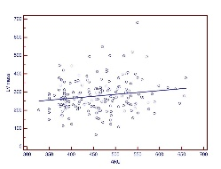
The effect of preload reduced on left ventricular muscle deformation assessed by 2D speckle tracking echocardiography in patients with chronic renal failure
Authors: Szymon Tuchacz, Monika Lichodziejewska-Niemierko, Michał Chmielecki, Marcin Fijałkowski
Medical University of Gdansk, Gdansk, Poland

Chronic renal failure (CRF) has a significant influence on morbidity and mortality due to cardiac reasons. Treatment of CRF has an important impact on volume overload in this population. Preservation of normal left ventricle ejection fraction in CRF population is dependent on compensatory mechanisms.
Aim of the research: The aim of the study was to analyze the effect of preload reduced as a result of renal replacement therapy on left ventricular muscle deformation as assessed by the use of 2D strain speckle tracking echocardiography (2D STE) in patients with chronic renal failure. The study also aimed to analyze the differences in the effect of sudden hemodynamic changes in hemodialysis (HD) and less severe in peritoneal dialysis (PD) on these parameters.
Material and methods: The project included patients with end-stage renal disease, dialysed in the Department of Nephrology, Medical University of Gdansk.
The inclusion criterion was:
- no symptomatic heart disease (coronary heart disease, previous heart attack, heart failure).
- sinus rhythm
- preserved left ventricle (LV) systolic function
- no significant valvular pathology
We enrolled 25 patients undergoing HD (13 women, 12 men) - the average age was 49 years (± 15.6).
32 patients (13 women, 19 men) undergoing PD -the average age was 44 years (± 14.01). And 24 persons (13 women, 11 men) as the control group (CG) - the mean age of the control group was 51 years (± 11.8). Echocardiography was performed in all examined patients. In the HD group just before (pre-HD) and immediately after haemodialysis (post-HD). Selected classic echo parameters and the selected parameters obtained by the 2D STE method were evaluated.
Results: The LVEF value was statistically significantly lower in all the groups studied (preHD, postHD, PD) compared to CG (60.1 ± 5.3%, 59.2 ± 5.5%, 60.3 ± 6,2%, 64.8 ± 5.2% respectively)
The highest LV diameters were observed in PD and preHD group. Values close to the control group were observed after haemodialysis. Statistically significant the lowest LV mean longitudinal strain (GLPS mean 14.83 ± 2.61%) were found in the PD group, the highest (20.31 ± 1.87%) in healthy volunteers, p<0.05. Patients undergoing HD, both pre-HD and post-HD had GLPS in the middle rage: ( 18.09 ± 2.51% and 16.62 ± 2.51% respectively).
The apical rotation (Ar) value was statistically significantly higher for the PD group (compared to the preHD group (14.18 ± 6.98 ° vs 8.9 ± 6.47 °, p<0.05) and CG ( 14.18 ± 6.98 ° vs 8.32 ± 10.34° ,p<0.05). Left ventricle twist was statistically significantly higher for the PD group compared to the preHD (21.83 ± 8.27 vs 15.22 ± 6.28, p<0.05) and CG (21.83 ± 8.27 vs 14.85 ± 8.57, p<0.05). Left ventricular twist after HD (19.06 ± 6.7 °) was not statistically significantly different from the value for the PD group. The highest TORSION values were found in the PD group (0.26 ± 0.11) and after haemodialysis (0.25 ± 0.09). TORSION values were the lowest in healthy volunteers (0.18 ± 0.1) and the preHD group (0.19 ± 0.07).
Conclusions:
1. Evaluation of left ventricle systolic (LV) mechanics with 2D STE is a useful method to assess left ventricle systolic function in patients with end-stage renal failure.
2. Both acute haemodynamic changes in the course of hemodialysis and less rapid changes during peritoneal dialysis have a significant impact on the parameters of LV muscle contraction mechanics.
3. The maintenance of normal ejection fraction in patients with renal insufficiency is possible due to the presence of compensatory mechanisms that can be assessed accurately by 2D STE methods.

Stress echocardiography in patients with pulmonary hypertension – a pilot study
Authors: Małgorzata Knapp, Katarzyna Ptaszyńska-Kopczyńska, Klaudia Mickiewicz, Monika Oleksiuk, Tomasz Michalski, Anna Lisowska, Karol Kamiński, Bożena Sobkowicz
Medical University of Bialystok, Bialystok, Poland

Introduction: Pulmonary arterial hypertension (PAH) is a rare, progressive disease with poor prognosis. Stress echocardiography (SE) gives an important data on hemodynamic response to exercise. In patients with PAH SE may be useful for the diagnosis and risk assessment but data are lacking.
Aim of study: The aim of the study was to analyze exercise-induced response of right heart function and pulmonary artery pressure in patients with PAH.
Materials and methods: Study group consisted of 13 hemodynamically stable patients, 9 women, aged 22-73 (median- 51), diagnosed with PAH treated at Cardiology Department. The patients were subjected to stress echocardiography on supine cycloergometer and underwent assessment before and at peak-exercise. Moreover the standard parameters of clinical assessment: NT-proBNP, WHO functional class, and 6-minute walk test were analyzed.
Result: Eight patients were in WHO class III, 3 of them- WHO class II and 2- WHO class I. The median NT-proBNP concentration was 284,3 (140,64-1095,53) pg/ml. 6-Minute Walk Test distance was 467,5 (435-507) meters. The median workload was 75 (IQR 50-100) Watts and it was the median 45% (IQR 35-64%) of predicted.
The echocardiographic parameters assessed in SE at rest and shortly after peak-exercise revealed that right ventricular (RV) diameter was 2.23 (2.14-2.33) vs 2.235 (1.83-2.97) (p=0.07). RV systolic volume significantly changed post exercise - 62.15 (46.25-117.5) vs 69 (35.8-94) ml, p=0.01, while changes in diastolic volume were not significant. Right atrial area decreased from median 20.4 (16.8-27.3) to 18.8 (15.6-23.9) cm2, p=0.035, whereas right atrial volume did not significantly changed - 75 (45-107) vs 64 (46.75-91.5) ml, p=0.157. Further, shortly after exercise tricuspid regurgitation peak gradient (TRPG) significantly increased - 49 (29-81.75) vs 71 (53-112), p=0.001.
Conclusions: In stable PAH patients supine SE is feasible. Even in advanced WHO functional classes patients were able to exercise. Among echocardiographic parameters TRPG reflecting systolic pulmonary artery pressure showed the biggest difference between baseline and peak-exercise values. SE and seems to be a valuable tool in PAH patients’ assessment.

Do urgent echocardiogram requests impact echocardiography laboratory workflow? A quality assurance study highlighting a large, quaternary academic center’s experience
Authors: Gregory Sinner, Elliott Goodwin, Sara Klinger, Vincent Sorrell, Mikel Smith
University of Kentucky, Kentucky, USA

Background: The process by which nonroutine TTEs are ordered and completed can affect workflow in the echocardiography laboratory. Although standards for timeliness of results reporting have been outlined in published guidelines, there is no evidence that high-volume echo labs meet these goals. As a quality assurance initiative, we sought to examine how our lab processes requests for both routine and nonroutine TTEs.
Methods: Nonroutine, adult, inpatient TTEs ordered at a large, quaternary academic center from November 1, 2018 through December 26, 2018 were retrospectively reviewed. Test indications, findings, and performance times were compared to a cohort of 71 randomly-selected routine studies. Significant findings were defined based on a 2018 “Call-to-action” editorial in the Journal of the American Society of Echocardiography.
Results: During the study period, 180 (3.2 per day) nonroutine studies were ordered. Nonroutine TTEs were performed and reported faster than routine TTEs (Figure). For nonroutine studies, longer performance times were associated with after-hour (5pm-7am) orders and lack of direct communication between ordering providers and laboratory staff. Significant findings were most commonly new LVEF < 40%, RVSP > 65 mmHg, or severe valvular pathology. Overall, the frequency of new significant findings did not differ between nonroutine and routine TTEs (20.1% vs 19.7%; p=0.858). Significant findings of nonroutine TTEs included intracardiac mass or vegetation with the potential to embolize, new severe mitral regurgitation after myocardial infarction, and cardiac tamponade. The significant finding discovered by routine TTEs was a new wall motion abnormality or reduced LVEF in two-thirds of studies. 90-day mortality did not differ between the nonroutine and routine TTE cohorts (23.9% vs 16.9%; p=0.309).
Conclusion: Our quality assurance study illustrates the efficiency of our high-volume echocardiography laboratory relative to routine and nonroutine studies. While comparative benchmarks for productivity in contemporary practice are lacking, further study to define laboratory performance guidelines for nonroutine studies is warranted. Additionally, general guidelines for stat TTE orders may equate to improved laboratory workflow in a busy, quaternary care hospital like ours, where patient acuity is high and provider tendencies related to echocardiogram orders may be inconsistent.
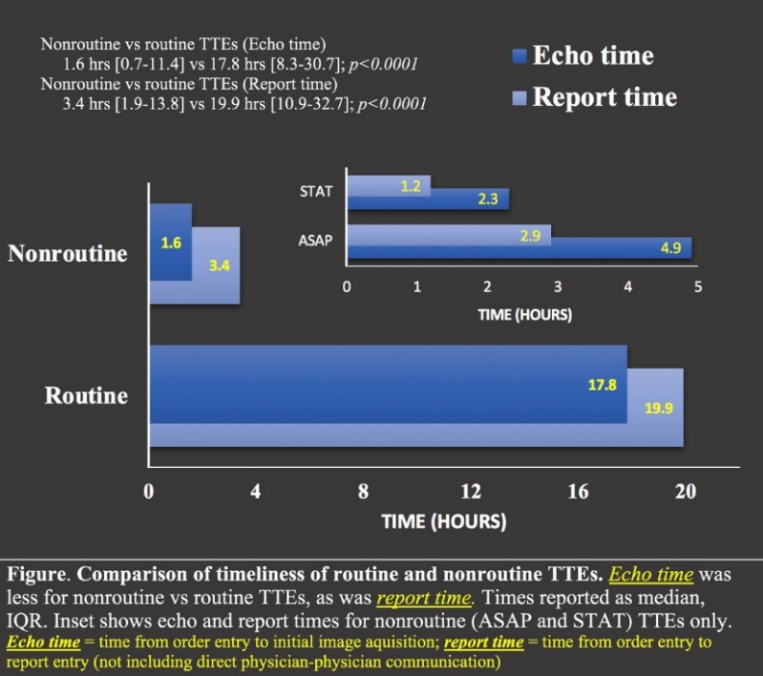
Clinical and echocardiographic characteristics of Polish patients with Eisenmenger Syndrome – results of a snapshot registry
Authors: Aleksandra Mamzer, Grzegorz Kopeć, Beata Kuśmierczyk, Wiktor Skowron, Ewa Mroczek, Ewa Lewicka, Karol Kamiński, Danuta Karasek, Tatiana Mularek-Kubzdela, Katarzyna Mizia- -Stec, Marcin Kurzyna, Zbigniew Gąsior, Malgorzata Peregud-Pogorzelska, Michał Ciurzyński, Edyta Płońska-Gościniak, Jarosław Kasprzak
Medical University of Lodz, Lodz, Poland

Purpose: The first national registry of patients (pts) with PAH-CHD, predominantly with Eisenmenger Syndrome (ES), treated within national program was conducted. We studied clinical and echocardiographic characteristics of a group of adult patients including current therapy profile and mortality.
Methods: A multicenter observational study (snapshot registry) was conducted under auspices of Polish Cardiac Society, including pts with PAH-CHD, identified in centers, that treated> 5 pts in the first 10 years of therapeutic program (2008-2018). This analysis included 322 pts, 252 surviving and 70 deceased, mean age 42±2 years, 65% females. The registry included patients meeting the criteria of the Eisenmenger syndrome in echocardiography (right-left or aligned leak). The living patients were divided into 2 groups: Gr.1 (n=227) – uncorrected and Gr.2 (n=25) - after correction of the heart disease.
Results: The average age of pts in Gr.1 was 40±2 years, in Gr.2 40±6 years. The majority were women (68% in gr. 1 and 62% in gr. 2). There was no significant differences for mean duration of treatment in both groups: 60±12 months vs. 66±6 months (p=0.42). Both groups didn’t differ in terms of clinical data, i.e. 6MWT 417±50 m vs. 384±15 m; p=0.15), NT-proBNP level 869±470 pg/ml vs. 901±212 pg/ml; p=0.57). There was no significant differences for mean LVd in both groups: 41,24 mm [12-82] vs. 44,25 mm [30-55]. Mean LVEF was good in both groups (60% vs. 57%). Mean TAPSE was slightly better in Gr.1: 19,36 mm vs. 17,09 mm. Pericardial effusion were present in almost 15% pts from Gr.1 and less than 1% pts from Gr.2.
Pts after correction were mostly in the II class of WHO, and those uncorrected in the II/III class of WHO. Pts from Gr.2 were more likely to receive polytherapy (60% vs. 47%). ERA were the most commonly used (almost 90%).
The most common heart defect was VSD (46% in Gr.1, and 32% in Gr.2). Mortality was 22% in entire period, corresponding annual mortality rate of 2.2%. In the group of dead pts women accounted for 74%, the average age was 49±4 years and mean length of treatment was 42±13 months. About 9% of pts from this group had heart defect correction in the past. Monotherapy (66%) predominated among the deceased, mainly using ERA (77%). Pts receiving combination therapy had a longer survival (p=0.04). It isn’t known whether this result confirms the greater effectiveness of such treatment, as some patients couldn’t wait until the polytherapy became possible within the framework of the Drug Program. Among the deceased, the most common heart disease was ASD (30%), slightly less VSD (29%).
Conclusions: In this first national snapshot registry we documented improving prognosis in PAH-CHD under specific therapies. No differences were present in the length of the targeted therapy, clinical data and quality of life depending on whether or not correction surgery was performed. Post-correction pts more often received a polytherapy. The annual mortality in this population is small estimated just over 2%. Targeted combination therapy was more prevalent in survivors and may contribute to better survival.

Differences in regional myocardial longitudinal strain in thalassemia major patients
Authors: Zahra Hoodbhoy, Ibrahim Habib, Hina Ali, Huda Ahmed, Salima Ashiqali, Devyani Chowdhury, Barbar Hasan
Aga Khan University, Karachi City, Pakistan
Background: Cardiac T2* MRI (T2*CMRI) is the gold standard to assess myocardial iron siderosis in transfusion dependent thalassemia major (TDTM) patients. Such imaging modality may not be available in low middle-income countries (LMIC). Early changes in regional myocardial function (preceding global dysfunction) have been reported in myocardial deposition disorders like Amyloidosis. These differences have been demonstrated in the left ventricular (LV) peak systolic longitudinal strain along the inter-ventricular septum. Such findings if present in TDTM, may be of use in LMIC where cardiac echocardiogram is readily available. The objective of this study was to assess such regional differences in myocardial function in TDTM patients as compared to healthy controls.
Methods: This was an analytical cross-sectional study that was conducted at The Aga Khan University, Pakistan. To detect a difference of 10% in the peak systolic LV basal longitudinal septal strain vs apical strain, a sample size of 25 was needed for each group. Information regarding socio-demographic and clinical characteristics was obtained along with regional and global strain analysis using Automated Functional Imaging (AFI) strain technique. Student’s t test was used to compare difference in means between TDTM patients and healthy controls.
Results: Mean age of the participants was 17.5 +/- 6 years. Majority of the TDTM patients (n=20, 80%) had a BMI of ≤ 18.5 kg/m2, belonged to New York Heart Association (NYHA) functional classification 1 or 2 (n=22, 88%) and were on single drug for chelation (n=22, 88%). Deferasirox was the most common drug used for chelation. There was a statistically significant difference between peak systolic LV apical longitudinal strain (-20.3 +/- 4.6 vs. -24.2 +/- 4.8; p=0.006) between the TDTM patients and healthy controls (figure 1). However there was no difference in basal septal strain, conventional echocardiographic parameters and peak systolic LV global longitudinal strain between the 2 groups.
Conclusion: We demonstrate regional changes in myocardial function in TDTM patients as compared to controls prior to any changes in global function. Such changes can be used as early marker of effects caused by iron deposition in the myocardium of TDTM patients.
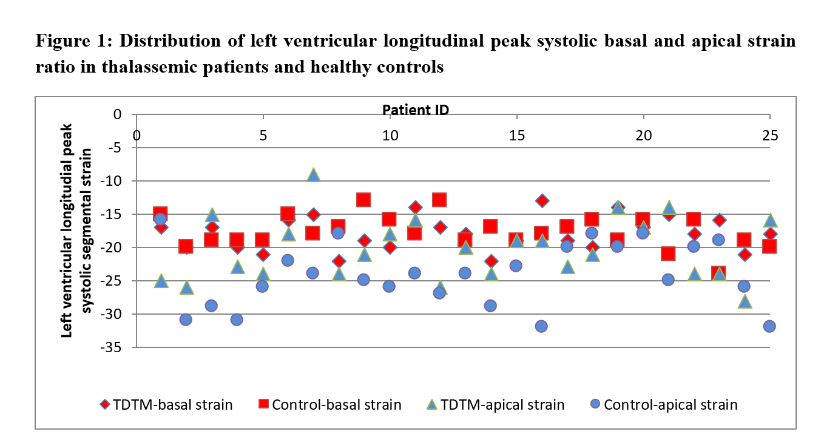

The associations between overweight and obesity and selected echocardiographic parameters of left ventricular diastolic dysfunction in patients with ischemic heart disease
Authors: Marlena Paniczko, Jacek Jamiołkowski, Małgorzata Chlabicz, Magda Łapińska, Małgorzata Szpakowicz, Paweł Sowa, Kamil Kamiński
Medical University of Bialystok, Bialystok, Poland

Heart failure (HF) is currently one of the most serious health problems in highly developed countries. Echocardiography plays an invaluable role in the diagnosis of this disease, enabling the detection of particular morphological and/or functional changes while preserve the ejection fraction (HFpEF).
The aim of the study was to investigate the relationship of the presence of left ventricular diastolic dysfunction (LVDD) assessed according to the recommendations of ASE / EACVI (2016) and selected echocardiographic parameters associated with LVDD, i.e. averaged E/e′, septal e′ velocity (e\'sep), lateral e′ velocity (e\'lat), TR velocity (TR Vmax), LA volume index (LAVI) with overweight and obesity in patients with ischemic heart disease (IHD).
242 patients with diagnosed IHD underwent echocardiography to assess the diastolic dysfunction. Anthropometric measurements were made, body composition analysis by densitometric method was performed, taking into account fat and lean tissue. There were shown slight relationships between BMI, % fat, % non-fat tissue and the velocity of the mitral ring (Tab.1). A logistic regression analysis (a model corrected for age, sex and hypertension) taking into account the presence of LVDD, showed an increase in LVDD in patients with a higher WHR index and an increase in the android-gynoid fat ratio (Tab.2).
Conclusions: The presence of abdominal obesity in patients with IHD is not strongly related to individual echocardiographic parameters of left ventricular diastolic dysfunction. It is recommended to use the entire LVDD diagnostic algorithm in this group of patients.

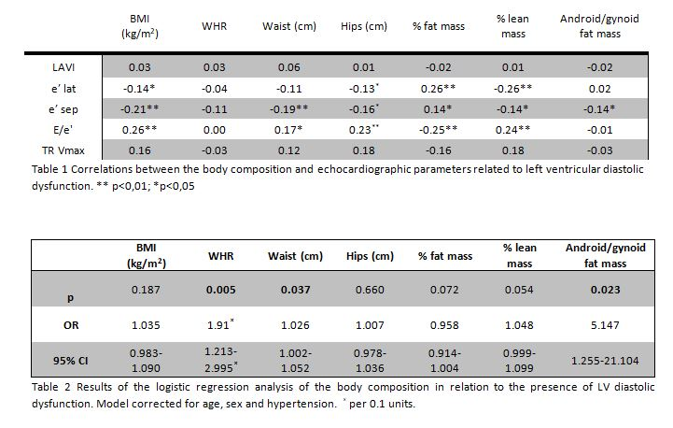

The utility of Pocket Echocardiography in the hands of a briefly trained student at the department of infectious disease
Authors: Adrianna Lorens, Jarosław Kasprzak, Paulina Wejner-Mik, Zbigniew Deroń, Maciej Jabłkowski, Anna Piekarska, Piotr Lipiec
Medical University of Lodz, Lodz, Poland

Purpose: The clinical utility of bedside echocardiography performed with the use of pocket-size imaging device (PSID) by cardiologists in patients with cardiovascular diseases has been already demonstrated. The aim of this study was to assess if non-cardiologist, after brief training in echocardiography, is able to provide clinically useful information by performing screening with the use of PSID in patients admitted to the department of infectious diseases.
Methods: The study group comprised 44 patients (29 men, 15 women; mean age 53±16 years) admitted to the infectious disease department, who presented with a fever (>38oC). Each patient underwent bedside echocardiographic examination with the use of PSID by a final-year medical student. All recorded images were then reviewed by an experienced cardiologist blinded to student’s conclusions. In case of suspicion of an emergent cardiac pathology or non-diagnostic images, the patient was referred for a standard echocardiographic examination.
Results: In 3 patients the quality of acquired images was insufficient for reliable analysis.
Within the remaining group, the medical student identified 47 cardiac abnormalities in 23 (52%) patients, including 28 at least mild valvular regurgitations, 6 cases of hypertrophy, 7 cases of wall motion abnormalities, 1 case of mass in right ventricle and 5 cases of additional valvular structures suggesting possible infective endocarditis (IE). The cardiologist reviewing the images confirmed all of the above abnormalities except for: 3 cases of wall motion abnormalities, 1 case of additional valvular mass and 1 case of right ventricular mass. 5 patients underwent subsequent urgent standard transthoracic echocardiographic examinations (sTTE) by a cardiologist experienced in echocardiography. Additionally, 4 patients underwent transesophageal examination. These examinations confirmed 3 cases of IE and did not confirm IE in 1 case.
Conclusions:The PSID allows significant enhancement of a physical examination performed by non-cardiologist at the infectious disease department, providing clinically relevant information.

Left atrial diameter as a simple parameter predicting the effectiveness of antazoline-based pharmacological approach to cardioversion of atrial fibrillation
Authors: Dawid Miśkowiec, Edyta Ćwiek-Rębowska, Michał Simiera, Piotr Lipiec, Jarosław D. Kasprzak
Medical University of Lodz, Lodz, Poland

Introduction: Antazoline (ANT) is an old antihistaminic medication with antiarrhythmic properties. After intravenous administration ANT exerts rapid antiarrhythmic effect often resulting in conversion of persistent atrial fibrillation (AF) to sinus rhythm (SR). However, published data on its effectiveness predictors, safety and clinical utility for rapid AF termination are limited and ANT is not recognized as a cardioversion drug.
Aim: To assess the real-world efficacy of ANT for pharmacological cardioversion of paroxysmal and persistent non-valvular AF and to identify predictors of its effectiveness.
Methods: We conducted a single center, retrospective, observational study including patients (pts) with history paroxysmal or persistent AF episode lasting less than 6 months, in stable cardiopulmonary condition who were qualified for elective pharmacological cardioversion with intravenous ANT. The primary end-point was the conversion of AF to SR confirmed in electrocardiography (ECG) during the 6-hours observation.
Results: A total of 98 pts (mean age 68.1±11.2 years, 55% male) were enrolled into the study. In 49 patients (50%) AF duration was shorter than 48 hours, in 27 pts (28%) AF duration was between 48h and 2 months, and in 22 (22%) AF lasted 2-6 months. The overall success rate of pharmacological cardioversion of AF with intravenous ANT was 39.8% (39/98 patients). The mean dose of ANT was 249.5±54.9 mg administered over 10.2±3.1 minutes. The subgroup analysis, regarding the AF duration, suggested the effectiveness of ANT mainly in in short-lasting AF (effectiveness of antazoline based cardioversion for AF lasting <48h vs 48h-2months vs 2-6 months, respectively: 69.4% vs 14.8% vs 4.5%, p<0.001). In multivariable logistic regression model AF duration<48hours (OR=13.4; 95% CI 4.31 – 42.16) and the left atrium antero-posterior diameter≥44mm (OR=0.88; 95% CI 0.79 – 0.98; negative predictive value 79%) were identified as independent predictors of successful antazoline based pharmacological cardioversion of AF, even after adjustment for comorbidities.
Conclusions: Intravenous antazoline administration is effective and safe in rapid pharmacological cardioversion of paroxysmal AF, especially in patients without significant enlargement of the left atrium and in the short-lasting AF (<48 hours). The assessment of antero-posterior diameter is a simple echocardiographic parameter of left atrium size which allows to identify patients who are likely to benefit from this new therapeutic approach.

The impact of cardiac surgery on the right ventricle function
Authors: Paulina Wejner-Mik, Jarosław D. Kasprzak, Ewa Szymczyk, Katarzyna Wdowiak- -Okrojek, Grzegorz Religa, Arkadiusz Ammer, Tomasz Kaszczyński, Daniel Steter, Piotr Lipiec
Medical University of Lodz, Lodz, Poland

Background: An impairment of some echocardiographic parameters of right ventricular (RV) function, such as tricuspid annular peak systolic excursion (TAPSE), is a known phenomenon in patients undergoing cardiac surgery. However, little is known about significance of these alterations with regard to other aspects of RV function. The aim of our study was to clarify this issue using parameters based on 3D echocardiography and speckle tracking technique.
Methods: The study population comprised 105 patients (76 men, mean age 65±16 years), referred for coronary artery bypass grafting and/or replacement of mitral or aortic valve. Patients undergoing tricuspid annuloplasty and with baseline suboptimal image quality were excluded from the study group. Baseline transthoracic echocardiographic examination (TTE1) was performed on average 2±2 days prior to surgery, whereas follow-up TTE (TTE2) was performed on average 7±4 days after the surgery. Parameters measured during the examination included both standard and advanced indices of RV size and function, such as TAPSE, systolic velocity of tricuspid annulus (S\'), fractional area change (FAC), RV ejection fraction (EF) and RV global longitudinal systolic strain (GLS).
Results: Echocardiographic measurements were completed for both TTE1 and TTE2 in 97% of patients. We noticed a significant postoperative impairment of parameters of RV longitudinal function (TAPSE, S’ and GLS; p<0,0001). However, neither RV size assessed by both 2D and 3D technique changed, nor the global RV function measured with the use of FAC and EF.
Conclusion: Cardiac surgery results in changes of RV function (impairment of its longitudinal component), but not RV dysfunction. In everyday clinical practice, complete echocardiographic examination in patients after cardiac surgery should not be based only on the measurement of the simplest and most commonly used parameters of RV function, such as TAPSE and S’.

Correlation between valve phenotype and the prevalence of aortopathy in the population of patients with bicuspid aortic valve and isolated severe aortic stenosis
Authors: Maria Nowak, Aneta Stróżyk, Radosław Nowak, Rafał Gałąska, Marcin Gruchała, Marcin Fijałkowski
Medical University of Gdansk, Gdansk, Poland

Introduction: Bicuspid aortic valve (BAV) is the most common congenital cardiac disease in the adult population. That malformation may contribute to severe regurgitation or stenosis (AS) due to earlier leaflets’ degeneration. Another frequent abnormality associated with BAV is dilatation of the thoracic aorta. Prevalence of aortopathy may determine method of AS treatment (aortic valve replacement or transcathether aortic valve implantation). The association between BAV phenotype and the manifestation of listed complications remain unclear.
The aim of our study was to assess the correlation of aortic valve phenotype and aortopathy prevalence among patients with BAV and severe AS.
Materials and methods: All cases with BAV and isolated severe AS from BAV Registry were chosen to further analyses – patients were hospitalized in years 2012-2018 in First Department of Cardiology, Medical University of Gdansk (MUG). Patients were categorized by BAV phenotype: coronary cups fusion (Type 1) right- noncoronary cups fusion (Type 2), left- noncoronary cups fusion (Type 3). Echocardiographic parameters were measured: peak transvalvular velocity (Vmax), mean transvalvular pressure (PGmean), aortic valve area (AVA), aortic annulus, aortic root and ascending aorta diameters, left ventricular ejection fraction (LVEF). Clinical characteristics were recorded based on medical history.
Results: 75 patients with isolated severe AS (48% female) were enrolled into the study which was 23% of the MUG-BAV Registry. Patients were relatively young (average age was 59.8±10.6) years) with the average LVEF 56,8 ±13.3%. Patients with Type 1 were 62 % and with Type 2 were 18 %. Patients with Type 3 phenotype were not included into the further analyses due to low prevalence (5%). In 15% of patients we were unable to clearly identify BAV phenotype.
There was no significant differences in the hemodynamic profile of AS between Type 1 and Type 2 group: Vmax- 4.5±0.5 m/s2 vs 4.3±0.6 m/s2; p=0.2; PGmean- 54.2±13.6 mmHg vs 46.6±13.8 mmHg; p=0.08 and AVA- 0.7±0.1 cm2 vs 0.8 ±0.1 cm2; respectively; p=0.5. The prevalence of aortopathy was significantly higher in Type 1 group than Type 2 group [37 patients (80%) vs 6 patients (46%) in; p<0.05]. Type 1 was associated with larger diameters than in Type 2 of both ascending aorta (42.3 ±4.4 mm vs 38.5±5.9 mm; p<0.05) and aortic root (38.5 ±4.6 mm vs 34.8±3.9; p<0.05), respectively. There was no difference in aortic valve annulus diameter between two groups (24.2±3 mm in Type 1 vs 23.5±2.1 in Type 2; p=0.5). The systolic blood pressure values were not significantly different between analyzed groups (133.8±19.0 and 139±11.4 mmHg for Type 1 and Type 2 group, respectively; p=0.1).
Conclusion: In the population of patient with BAV and severe aortic stenosis, BAV with coronary caps fusion is associated with the higher prevalence of thoracic aorta abnormalities which may affect the election of invasive treatment method. Hemodynamic profile of severe AS does not present correlation with the type of BAV phenotype.

Multimodality imaging in assessment of infective endocarditis inflammatory lesions in patients with various types of cardiac implantable electronic devices
Authors: Katarzyna Holcman, Wojciech Szot, Barbara Małecka, Paweł Rubiś, Andrzej Ząbek, Krzysztof Boczar, Agata Leśniak-Sobelga, Marta Hlawaty, Sylwia Wiśniowska-Śmiałek, Agnieszka Stępień, Piotr Podolec, Magdalena Kostkiewicz
Jagiellonian University Medical College, Krakow, Poland

Background: Cardiac device-related infective endocarditis (CDRIE) is a rising epidemiological and diagnostic challenge. For the last decades echocardiography has been—and still is—the cornerstone of the imaging techniques in CDRIE evaluation. Hybrid technique of single photon emission tomography and computed tomography with technetium99m-hexamethylpropyleneamine oxime–labeled autologous leukocytes (99mTc-HMPAO-SPECT/CT) is an emerging technique in patients with suspected CDRIE.
Purpose: The aim of this prospective study was to evaluate distribution of inflammatory lesions detected with echocardiography and 99mTc-HMPAO-SPECT/CT in patients with suspected CDRIE depending on the type of carried cardiac implantable electronic device (CIED).
Methods: During the period 2015-2018, we enrolled 103 consecutive adults with suspected CDRIE (70 males, 61±18 y.o.). Patients undergone clinical, microbiologic, transthoracic echocardiography (TTE) and transesophageal echocardiography (TEE) evaluation according to current ESC guidelines and subsequently 99mTc-HMPAO-SPECT/CT. Scans were classified as positive in the presence of abnormal tracer uptake involving cardiac or/and intravascular sections of device electrodes. Patients were divided to group 1 with implanted pacemakers (61 patients) and group 2 including 42 carriers of either an implantable cardioverter-defibrillator (ICD) or a cardiac resynchronization therapy device (CRT).
Results: Overall, in group 2 there was a predominance of males (90% vs. 52%), as well as a higher prevalence of heart failure (83% vs. 46%, p<0.05). Moreover, group 2 had worse functional status with higher NYHA class (2.8±0.9 vs. 1.7±1, p=0.001), NT-proBNP levels (5027±5813 vs. 2320±4279, p=0.0004) and lower left ventricle ejection fraction (29±12 vs. 54±13, p=0.0001). There were no differences between the groups in the serum concentration of inflammatory markers - C-reactive protein and procalcitonin (p>0.05). Echocardiographic exams were positive for CDRIE in 51 patients (49.5%), with no differences between the groups (p=0.20). Overall, 34% of 99mTc-HMPAO-SPECT/CT scans were positive for CDRIE. Patients from group 2 presented more often with 99mTc-HMPAO-SPECT/CT positive for CDRIE (45% vs. 26%, p=0.045). Frequency of lesions consistent with infection localized within the intravascular section of the electrode and the CIED lodge did not differ between groups (p>0.05). However, inflammatory foci in the vicinity of the intracardiac portion of the electrode were detected more often in group 2 (43% vs. 21%, p=0.019). Overall, extracardiac inflammatory foci were found in 34% of patients, with most common localization in the gastrointestinal tract (13%) and musculoskeletal system (8%).
Conclusions: Distribution of echocardiographic lesions diagnostic for CDRIE does not differ between groups. Prevalence and localization of intracardiac inflammatory foci typical for CDRIE detected with 99mTc-HMPAO-SPECT/CT is different in patients with various types of CIEDs. During CDRIE work-up multimodality imaging with radiolabeled leukocyte scintigraphy helps to differentiate echocardiographic morphologic lesions – those with on-going infections and inactive ones.

Application of 3-dimensional transthoracic echocardiography in the evaluation of implantable cardioverter defibrillator lead position
Authors: Marta Kamińska, Paulina Łopatowska, Bożena Sobkowicz
Medical University of Bialystok, Bialystok, Poland

Over the last decade there has been a significant increase in the number of implantable cardiac defibrillators (ICD) in patients with heart failure with reduced ejection fraction (HFrEF). These leads have been reported to cause or to increase tricuspid regurgitation (TR). Echocardiography is not routinely used to elucidate the mechanisms of lead interference with tricuspid valve leaflets in individual patients.
Aim: To evaluate of usefulness of 3-dimensional transthoracic echocardiography (3D TTE) in the assessment of ICD lead position and its relations to tricuspid valve.
Methods: A population consisting of 44 consecutive patients with ICD was evaluated (43 – patients with HFrEF, 1 – patient with hypertrophic cardiomyopathy). 3D TTE full-volume images of the right ventricle and/or zoomed images of the tricuspid valve were obtained. Images were analysed off-line to determine the position of the device-lead in relation to the tricuspid valve leaflets. Severity of TR was estimated as not important (+, ++) and important (+++, ++++).
Results: An evaluation of the device-lead position was impossible due to poor diagnostic quality of echocardiographic images in 4 patients (9%). Among 40 remaining subjects in 12 (30%) lead was in central position, without interfering with leaflet motion, in 14 (35%) - impinging on the posterior leaflet, 6 (15%) - impinging on the septal leaflet, 8 (20%) – lead was positioned near the posteroseptal commissure. Among 15 patients (38%) TR was assessed as important. There was no correlation between device-lead position and severity of TR.
Conclusions: 3D TEE enables to determinate ICD-lead position and its relation to tricuspid valve. 3D TEE can explain a mechanism of associated TR in individual patients. Further studies are necessary to investigate possible relationship between lead position and TR severity.

Dobutamine stress echocardiography including speckle tracking imaging reveals radiotherapy- -related abnormalities in mediastinal lymphoma survivors
Authors: Izabela Nabiałek-Trojanowska, Hanna Jankowska, Alicja Dąbrowska-Kugacka, Ewa Lewicka
Medical University of Gdansk, Gdansk, Poland

Objective: Cancer survivors are life-long at risk of cardiac complications as a result of anticancer treatment. Speckle tracking echocardiograpy (STE) enables to detect early changes in cardiac function. Dobutamine stress echocardiography is a useful tool in the diagnosis of coronary artery disease.
Aim of the study: Our ongoing study aims to search for signs of cardiovascular disease with transthoracic echocardiography, including tissue Doppler imaging (TDI), STE analysis and stress dobutamine, in patients with mediastinal lymphoma who underwent chemotherapy including anthracyclines with or without chest irradiation.
Methods: Echocardiographic examination included detailed analysis of left (LV) and right (RV) ventricular function. Stress dobutamine echocardiography was performed according to a standard protocol, and LV ejection fraction (LVEF), LV global longitudinal strain (LV GLS) and LV contractile reserve was measured at low and at peak dobutamine dose. LV contractile reserve force was calculated by dividing peak systolic blood pressure, measured noninvasively with cuff sphygmomanometer, by LV end-systolic volume obtained from apical views.
Results: We examined 10 patients, aged 46±13 years, 60% woman, who had completed anticancer treatment (median) 14 years ago (range 5-31 years) due to Hodgkin lymphoma (8 patients) or diffuse large B-cell lymphoma (2 patients). All patients were treated with anthracyclines, and 6 (60%) also with chest irradiation. Four patients were diagnosed with hyperlipidemia, 3 with arterial hypertension, and 1 patient was an active smoker. In echocardiography at rest, LVEF was 60.7% ±7.1% and LV GLS was -19.2±-2.2%. The lowest strain was found in the LV anterior wall: -15.0%±-4.9% and anterior septum (IVS): -16.7%±-2.9%. There were no significant abnormalities in parameters describing RV, except for impaired RV Myocardial Performance Index (RV MPI): 0.8±0.4. Stress dobutamine echocardiography revealed an increase in LVEF to 68.9%±6.2% at low dose and 70.6%±5.3% at peak dose of dobutamine. LV GLS was -23.8%±2.6% at low and -31.1%±3.6% at dobutamine peak dose, but it was lower in LV anterior wall and IVS. It was -17.2%±-5.1% and -16.4%±-4.7% in LV anterior wall, and -19.2%±-2.9% -16.1.0%±-5.3% in IVS, at low and peak dose, respectively. In all patients, LV contractile reserve force was decreased: 1.1±0.2 and 1.2±0.3 at low and peak dose, respectively.
Conclusion: Patients who underwent chest irradiation show mild LV contraction abnormalities within LV anterior wall and anterior septum. Cardiac monitoring is mandatory in this group of patients due to increased risk of coronary artery disease.

The correlation of transthoracic echocardiography findings with NT-proBNP among patients with reduced left ventricle ejection fraction
Authors: Ewelina Kowalczyk, Jarosław D. Kasprzak, Paulina Wejner-Mik, Katarzyna Wdowiak-Okrojek, Piotr Lipiec
Medical University of Lodz, Lodz, Poland

AIM: We aimed to evaluate a possible relationship between NT-proBNP and the transthoracic echocardiographic (TTE) parameters in patients with heart failure.
MATERIALS AND METHODS: A total of 50 patients (22% women; mean age 63±13 years) with reduced left ventricular ejection fraction (≤45% as determined by the TTE) were included in the study. The following parameters derived from TTE were analyzed: left atrium and right atrium size, left ventricular systolic and diastolic diameter, pulmonary artery diameter and left ventricular ejection fraction. Next, global longitudinal strain (GLS) were obtained off-line using 2D speckle-tracking echocardiography (STE).
RESULTS: Among mentioned TEE parameters only LVEF (P = 0.016, 95%CI -0.57 to -0.07) and GLS (P = 0.03, 95%CI 0.03 to 0.54) were found to be statistically significant. However correlation coefficient remains low for both variable (r= -0.34 and r=0.31, respectively).
CONCLUSION: NT-proBNP shows significant correlation with LVEF and GLS. No such correlation was found with the size of cardiac chambers or function of the right ventricle.

Cardiac morphology and function in morbidly obese patients with non-alcoholic steatohepatitis
Authors: Piotr Kalinowski, Grzegorz Styczyński, Łukasz Michałowski, Rafał Paluszkiewicz, Bogna Ziarkiewicz-Wróblewska, Krzysztof Zieniewicz, Daniel Rabczenko, Maciej Siński, Cezary Szmigielski
Medical University of Warsaw, Warsaw, Poland

Background: Although several studies demonstrated subclinical left ventricular dysfunction in NAFLD patients (pts), data from histologically confirmed NASH cases is scarce and with conflicting results. Therefore, we decided to prospectively evaluate cardiac morphology and function in a cohort of morbidly obese pts referred for bariatric surgery with concomitant liver biopsy.
Methods: We evaluated with echocardiography 130 consecutive, severely obese pts, (66% females, mean BMI 44.7±5.4 kg/m2). Echocardiographic morphologic and functional cardiac parameters were measured, including LVEDD, LVMI, aortic root dimension, LA area, RVEDD, and LV fractional shortening (FS). PW Doppler and tissue Doppler imaging (TDI) parameters (E/A, E`,E/E` and S mean) were used for the assessment of LV diastolic and systolic function.
Results: The mean age of 130 pts was 42.01±9.74 yrs. There were 34 pts with NASH (NASH), 52 pts with simple steatosis (STEAT), and 44 subjects with no steatosis (NORMLIV). Cardiac chamber sizes were similar in all groups, but after indexation for BSA, LVEDD/BSA, was smaller in NASH (NASH 1.9cm±0.16 vs STEAT 2.02cm±0.2; P=0.01; vs NORMLIV 2.01cm±0.16; P=0.02). LVMI was lower in no-steatosis group, as compared to simple steatosis (NASH 91.76g/m2±15.74; NS; STEAT 98.4g/m2±19.03 vs NORMLIV 88.4g/m2±16.52, P= 0.01), however, the difference disappeared after adjustment for age, heart rate and systolic blood pressure. LV Systolic parameters including FS and S mean were similar in all groups, except for S mean in simple steatosis, which was significantly lower when compared to no steatosis group (NASH 8.5cm/s [7.5-10], NS; STEAT 8.0cm/s[7.0-9.0] vs NORMLIV 9.0cm/s[8.0- 10]; P=0.01). This difference also disappeared after adjustment. Diastolic parameters revealed that E/A was lower in steatosis group as compared to no-steatosis, (NASH 1.14±0.29, NS; STEAT 1.07±0.26 vs NORMLIV 1.24±0.26, P=0.005), however, again, after adjustment, it was no longer significant. E` was significantly lower in both NAFLD groups, when compared to no-steatosis group (NASH 9.44cm/s±2.01 vs NORMLIV 10.8cm/s±2.5, P=0.02; STEAT 9.05cm/s±2.13 vs NORMLIV 10.8cm/s±2.5, P=0.0004). E/E` did not differ between groups.
Conclusions: In this cohort of extremely obese patients, NASH was not associated with overt adverse cardiac remodeling and dysfunction compared to simple steatosis and normal liver histology. Observed subclinical impairment of the diastolic and systolic cardiac function in both NAFLD groups was attenuated after adjustments for age, systolic blood pressure and heart rate.

Visual assessment of the left ventricular ejection fraction in daily echocardiographic practice in Poland
Authors: Rafał Dankowski, Joanna Zaprutko, Izabela Miechowicz, Artur Baszko, Stefan Ożegowski, Andrzej Szyszka
Poznan University of Medical Sciences, Poznan, Poland

Introduction. The recommended method for the echocardiographic assessment of left ventricular ejection fraction (LVEF) is the biplane method of disks. In daily practice, however, visual assessment of LVEF is often used. We sought to determine the frequency of use of visual estimation of LVEF and factors influencing the accuracy of LVEF assessment.
Material and methods. We conducted a survey during the XVI Conference of the Working Group on Echocardiography of Polish Cardiac Society. Echocardiographic cine loops with parasternal long axis, parasternal short axes (basal, middle and apex), and three standard apical views were presented (one echocardiographic examination). The audience were asked to assess the LVEF visually. We also asked questions about the most frequently used method of LVEF estimation and two questions about experience in echocardiography.
Results. 159 surveys were returned. Majority of the respondents declared that using visual estimation of the LVEF as the primary method (87 respondents; 54.7%), 37 (23.3%) answered that they used the biplane method of disks most commonly. The correct value of LVEF was provided by 93 respondents (58.5%), including the exact value and the range. Respondents who underestimated the LVEF significantly rarely used thhe visual estimation method (p=0.002). Experience in echocardiography did not affect correctness of LVEF estimation. Conclusion. Visual assessment is the most commonly used method for LVEF estimation. Based on the results of our study, it should be emphasized that training programs on echocardiography should include a thorough analysis of all potential pitfalls of this method.

ECG as a guide for echocardiography – a case of a 46 year old female with amyloidosis
Authors: Sergiusz Nowak, Wojciech Kula, Grzegorz Sobieszek, Bartosz Olajossy, Natalia Jurzak-Myśliwy, Agnieszka Dronka-Mazur
NIE MOGĘ ZNALEŹĆ, wydaje mi się że Lublin

A 46-year-old woman admitted to the Cardiology Department due to persistent dyspnoea, ascites, significant deterioration of exercise capacity and intensification of heart failure symptoms to NYHA class IV. In laboratory tests elevated levels of NTproBNP 3076 pg / ml, elevated troponin T (HS) to 65.61 pg / mL and hypertriglyceridemia at 239.2 mg / dL were observed. Other results within the normal range. ECG on admission revealed a congestive and regular rhythm, with a frequency of 75 / min, with the width of P wave 120ms, abnormal progression of R waves in precordial leads, elevation of the ST segment in V2-V4 leads, as well as low voltage waves in the limb leads. Echocardiographic examination revealed concentric left ventricular hypertrophy up to 19 mm and right ventricle up to 12 mm, third degree diastolic dysfunction, a small amount of pericardial peritoneum, left ventricle ejection fraction remaining at about 50%, moderate mitral valve regurgitation and mild mitral regurgitation . The profile of global longitudinal strain of the left ventricle was 8.5%. According to the HCM risk score calculator, the risk of sudden cardiac death was estimated at 1.97%. In the coronary angiography performed due to the high troponin level, no significant stenosis were found in the epicardial coronary arteries. In 24-hour Holter monitoring, the mean heart rate was 75 / min. There were 1180 ventricular premature beats, 220 supraventricular premature beats and an episode of supraventricular tachycardia, without the presence of complex ventricular arrhythmias. The patient underwent standard pharmacotherapy of heart failure: metoprolol, torasemide and perindopril, resulting in significant clinical improvement. In her medical history, the patient had carpal tunnel syndrome, which has been surgicaly attended. Based on the above, the patient was suspected of having cardiac amyloidosis. In the course of sigmoidoscopy, gastrointestinal mucous membranes were harvested and subcutaneous tissue of the abdomen was taken into further testing. DNA electrophoresis with immunofixation have been commissioned.
Due to the elevated levels of CA125, after gynecological consultation, blood was taken for the ROMA test. Due to the presence of chronic hoarseness and the suspicion of larynx infiltration, the patient underwent CT examination. The patient was referred to the Department of Hematology for further treatment and diagnosis. Before the planned hospitalization took place, the patient suffered an ischemic brain stroke and was hospitalized in the Neurological Department. During hospitalization in the Department of Hematology where the diagnosis was extended, the performed research allowed to diagnose multiple myeloma. The patient is considering proposed hematological treatment.

A rare case of an angioma of the right heart
Authors: Joanna Ateńska-Pawłowska, Piotr Kołsut, Agnieszka Chrapowicka, Karina Zatorska, Hanna Siudalska, Mariusz Kuśmierczyk
Medical University of Warsaw, Warsaw, Poland

Angiomas are rare benign primary cardiac tumours of vascular origin presenting with unspecific symptoms. Echo is accurate in detecting such lesions. Our patient presented with chest pain but normal coronary angiogram. Echo revealed a fixed, encapsulated homogenous echodense mass within the anterior wall of right ventricle. She was treated with external surgical excision with Gore-Tex patch. Histopathologic examination of the mass demonstrated angioma. The postoperative course was uneventful.

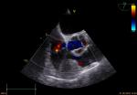

Echocardiographic diagnosis of coronary artery fistula
Autorzy / Authors: Shoa-Lin Lin, Lee Tao-Yu
University at Albany, The State University of New York, New York

A congenital coronary artery fistula is an uncommon cardiac anomaly. The diagnosis of coronary artery fistula has been made previously by cardiac catheterization. With recent advances in echocardiography, coronary artery fistula can be imaged noninvasively using two-dimensional transthoracic echocardiography (TTE). However, direct visualization of the entire coronary artery fistula from the precordium is difficult. This report described a patient with coronary artery fistula that was clearly diagnosed by multiplane transesophageal echocardiography (TEE) before cardiac catheterization.
Multiplane TEE found that the origin of this coronary artery fistula was arose from the right coronary artery and drained to the left ventricle. The whole outline of this tortuous and dilated right coronary artery fistula can also be appreciated from the computed tomographic (CT) angiograms. Cardiac catheterization and surgery confirmed the diagnosis of multiplane TEE findings.
Thus, the experience of this case demonstrates the usefulness of TEE for the precise evaluation of the opening and draining site as well as the three dimensional understanding of the features of coronary artery fistula.

Role of trans-oesophageal echocardiography monitoring in detection and management of acute complications of left main coronary artery occlusion during trans-catheter aortic valve implantation
Authors: Mahmoud Nosir, Abdulaziz Al-Shaibi, Mervat Alasnag, Ahmed Waqar, Walid Abukhudair, Khlaid Al-Shaibi, Youssef Nosir
King Fahad Armed Forces Hospital, Andalus, Saudi Arabia

Background: Trans-catheter aortic valve implantation (TAVI) is a relatively new procedure for replacing severely stenotic AV in non-operable elderly patients. Trans-oesophageal echocardiography (TEE) is used pre-procedure to evaluate AV and to measure AV annulus for optimal selection of valve size. TEE during and post-procedure is used to detect complications during the procedure and for evaluation of AV bio-prothesis. TEE during TAVI procedure can detect acute complications that could require immediate managements.
Clinical Case: A 75 Years Old Female Patient with severe Symptomatic AS. Co-morbidity includes chronic renal insufficiency, HTN, IDDM and Interstitial Lung Fibrosis. Patient was Declined by the Surgeon because of High Surgical Risk. Suitable for TAVI by TTE, TEE and CTA. Normal coronaries by Coronary angiography.
Patient underwent TAVI procedure under GA. Edwards 23mm Sapien XT valve was deployed properly during rapid pacing, checked by TEE and released successfully. Aortography showed valve in proper position and coronary arteries filling were normal.
However, two minutes later patient developed severe hypotension. TEE immediately detected severe deterioration in LV systolic function with severe hypokinesia to apex, anterior wall and apical half of IVS. In addition, TEE could detect tethering of PMVL and acute severe MR. Immediate coronary angiography showed acute LM occlusion. Direct LM stenting was performed with restoration of normal TIMI-III flow. Post LM stenting TEE showed normal LV systolic function with normal wall motion score. Evaluation of MV by TEE showed no tethering of posterior leaflet with no mitral regurgitation.
Conclusion: TEE during TAVI can detect complications during the procedure, properly directing the intervention team towards solving the problem for rapid and prompt management.

Uncommon case of LV non compaction with bicupied aortic valve
Authors: Amir Othman, Mousa Alharbi, Ghazal Sami
Imam Abdulrahman Bin Faisal University, Ad-Dammam, Saudi Arabia

L eft ventricular noncompaction (LVNC) is a relatively new entity. It is characterized by trabeculated myocardium with adjacent deep intertrabecular recesses communicating with the LV cavity [1]. Prominent myocardial trabeculations were first identified in a variety of congenital heart defects and then in the absence of any other structural heart disease [2, 3]. These early reports appreciated the persistence of embryonic myocardial structures described as persisting myocardial sinusoids. In 1990 Chin et al. [4] introduced the term “isolated noncompaction of the LV myocardium” and recognized the underlying arrest of the normal compaction process during embryogenesis. Most commonly, the apical and midventricular segments of both the inferior and lateral walls are affected [5]. At the outset the spectrum of clinical symptoms is wide and nonspecific [5, 6]. Patients may have no symptoms or present with chest pain, heart failure, and arrhythmias. In the advanced disease stages, heart failure is present in more than 50% of patients, and depressed systolic function is the most common f inding [7]. LVNC can lead to fatal complications, such as embolic events, arrhythmias, and sudden death [8, 9]. These complications can be avoided with early diagnosis and timely treatment of patients at high risk. Risks include administration of anticoagulants to patients at risk of thromboembolism [10] and prophylactic insertion of an implantable cardioverter-defibrillator (ICD) in patients at risk of life-threatening arrhythmias [5].

Huge thrombus in left ventricle in a patient with essential thrombocytosis, a history of myocardial infarction and recurrent multiregional systemic embolic events
Authors: Robert Morawiec, Jarosław Drożdż, Michał Barański, Leszek Wojtasik, Katarzyna Piestrzeniewicz
Medical University of Lodz, Lodz, Poland

Background: Patients with cardioembolic events (CE) have high recurrence rates but may benefit from targeted therapy. Importance of identifying and treating sources of CE is clear and echocardiographic imaging is recommended as a first-line diagnostic tool.
Case summary: 57-year-old man with a history of hypertension, hyperlipidemia, smoking, alcohol abuse, myocardial infarction (MI) and embolic events was recently admited to the hospital with the symptoms of acute coronary syndrome. Coronary angiography showed nonsignificant coronary lesions and a patent drug-eluting stent (DES) in left anterior descending artery (LAD). On echocardiography (TTE) a huge thrombus (THR) in left ventricle (LV) was revealed. No effect was achieved with heparine. Details of medical history showed: MI treated with aspiration thrombectomy and DES implantation to LAD in 2017, embolectomy of lower limbs’ artries in 2018 followed by right lower limb amputation three months later, area of brain post-embolic injury on computer tomography and (at the post-infarction period) thrombocythemia and thrombus in akinetic LV apex, that resolved during heparyn infusion. Consultation in outpatient hematology clinic was recommended but the patient ignored it. He arbitrary discontinued oral anticoagullation. The patient was transferred to our institution to decide on the treatment strategy. We confirmed the presence of large thrombus in LV (size: 63mm/20mm) attached to the hipokinetic apex, extending to the LV outflow tract. Blood tests revealed thrombocytosis (platelet count – 1.5 mln/µL) with no apparent underlying condition. There were no data for reactive thrombocythemia and essential thrombocythemia (ET) was initially diagnosed. According to the hematology consultation treatment with high dose hydroxyurea was initiated and heparine infusion was continued. Further, bone marrow aspirate evaluation confirmed diagnosis of ET. The thrombocyte counts dropped, THR sligtly regressed, but its embolic potential was still very high. The decision of Heart Team was to perform surgical thrombectomy. Preoperative piriod was complicated with thrombocytopenia (0.96mln/µL), leucopenia (0.82*103/µL) and fever of unknown origin. Relative clinical and morphological parameters improvement was achieved after modyfication of hydroxyurea dose and antibiotic treatment with ceftazidim followed by meropenem together with acyclovir and fluconazole. The patient was transfered to the operating theatre. Thrombus stuck between the LV trabeculae was found and removed. No further complications were observed and the patiend was discharged from hospital. Unfortunately he did not attend the cardiology nor hematology outpatient clinic and was lost to follow-up.
Discussion: Akinetic LV apex provide the perfect milieu for THR formation, but THR are rarely as big as in the presented case and tend to resolve on anticoagulation. ET was another prothrombotic condition and a significant cofactor in thrombogenesis in our patient.
Conclusions: One disease may have several causes and frequently need multidiscipinary aproach. It seems that Social Services could be helpfull in identyfing possibly non compliant patients to improve healthcare and prevent from serious complications and high-cost procedures.

Assessment of the left ventricle 2-D global longitudinal strain in infants with dilated cardiomyopathy before and after surgical treatment with pulmonary artery banding
Authors: Alicja Mirecka-Rola, Monika Kowalczyk-Domagała, Anna Brodzikowska-Pytel, Anna Turska-Kmieć, Grażyna Brzezińska-Rajszys, Andrzej Kansy, Bohdan Maruszewski
Children’s Memorial Health Institute, Warsaw, Poland

Background: Dilated cardiomyopathy (DCM) is the most frequent form of cardiomyopathy in children leading to death or heart transplant (HTx) in the first 5 years after diagnosis. The small number of potential donors for HTx remains a serious problem in infant population. Pulmonary arterial banding (PAB) is a novel therapeutic strategy proposed in children younger than 2 year of age with DCM and preserved right ventricle function which improves left ventricle (LV) and mitral valve (MV) function by ventricular interaction and allows to avoid or delay HTx in pediatric DCM population.
Methods and Results: We evaluated left ventricle 2-D global longitudinal strain (GLS) in two children with DCM before and after surgical treatment with PAB. Patients M.A. (girl, age 8/12) and M.B. (boy, age 6/12) were admitted to our department. Initial echocardiography (TTE) and cardiac magnetic resonance (CMR) confirmed DCM diagnosis. Both patients presented with symptoms of heart failure (Ross-class IV), NT-BNP levels highly elevated (>35 000) and were treated with ACE-inhibitors (ACE-I), betablockers, diuretics, milrinone infusion and repeated levosimendan infusions. After 3 months of ineffective pharmacological treatment patients were qualified for pulmonary arterial banding procedure. At 4 month follow-up visit patient M.A. and M.B. were in Ross-class II, on oral medications only, NT-BNP decreased to 5099(M.A.) and 1047 (M.B.) respectively. TTE was performed which showed a significant improvement in both left and right ventricle function. Patient M.A. TTE data before PAB: LVDd 43mm (Z=+11), EF (BP) 17%, LV EDV index 168ml/m2, MAPSE 3.5mm, STE GLS -8.6%, STE EF (BP) 33%, RVD2 6.8mm, TAPSE 13mm (Z=-1), FAC 40%. Patient M.A. TTE data 4 mo after PAB: LVDd 41mm (Z=+9.5), EF (BP) 30%, LV EDV index 135ml/m2, MAPSE 5.3mm, STE GLS -14.4%, STE EF (BP) 39%, RVD2 9.6mm, TAPSE 13mm (Z=-1), FAC 53%, PAB ∆p 23mmHg. Patient M.B. TTE data before PAB: LVDd 55mm (Z=+12), EF (BP) 18%, LV EDV index 204ml/m2, MAPSE 4mm, STE GLS -7.5%, STE EF (BP) 34%, RVD2 13mm, TAPSE 10mm (Z=-2), FAC 50%. Patient M.B TTE data 4 mo after PAB: LVDd 47mm (Z=+8), EF (BP) 31%, LV EDV index 134ml/m2, MAPSE 4.8mm, STE GLS -19.5%, STE EF (BP) 44%, RVD2 17mm, TAPSE 13mm (Z=-2), FAC 51%, PAB ∆p 64mmHg. STE 2-D GLS before and after PAB are shown in figure 1.
Conclusions: 1. GLS is useful echocardiography parameter in assessing left ventricle function in children with DCM. 2.Pulmonary arterial banding is promising alternative treatment method in children with DCM and in our patients led to improvement of left ventricle function including GLS and Ross-class.
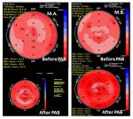

Young Women with an Acute Myocardial Infarction: Think Differently!
Authors: Fabiola B Sozzi, Marco Schiavone, Elisa Gherbesi, Ciro Canetta, Luca Mircoli, Federico Colombo, Carla Bonanomi
University of Milan, Milan, Italy
Introduction: Spontaneous coronary artery dissection (SCAD) is a rare serious complication triggered by non-atherosclerotic acute myocardial infarction (AMI) that affects mainly women. Along with a low clinical index of suspicion, the symptoms’ presentation of young women compounds the challenge of diagnosing SCAD. There are no randomized data and no consensus to define the optimal guide management for SCAD.
Hypothesis and Methods: To investigate the clinical characteristics of young women admitted to our Institution with AMI secondary to SCAD in 2-years period. A homogeneous case series of 5 women (median age 32±3 years) was analysed. The clinical and angiographic characteristics were compared. Results: STEMI accounted for 2 cases, NSTEMI for 3. Two patients were in the postpartum period 2 other women were affected by connective tissue disorders and one had an acute emotional stress. On coronary angiogram all women presented distinctive pattern of non-atherosclerotic single vessel disease: proximal LAD dissection causing anterior AMI in 2 cases (40%), proximal RCA dissection with an inferior AMI in 1 case (10%), first obtuse marginal branch dissection with lateral AMI in 2 cases (40%). The coronary dissection was suggested by a visible intraluminal filling defect with an abrupt demarcation from the normal segments in all cases, an additional tract of extraluminal opacity or flap was found in the 2 STEMI cases. Three women were treated with multiple PTCA-stent (of proximal LAD for the anterior STEMI and anterior NSTEMI and proximal RCA for the inferior STEMI). Medical therapy was the first choice in the first obtuse marginal branch SCAD. No one was affected by congenital cardiac disorders. The ejection fraction early after AMI was >50% in 4 cases, only the anterior STEMI developed its moderate reduction.
Conclusion: SCAD in young women showed a direct causative association with hormonal-related structural changes and with connective tissue disorders. The misconception of women being at low risk for AMI is pervasive. Such presentations in women at risk should prompt early invasive coronary angiography to rule out SCAD. Medical therapy was the first choice in mid-distal SCAD.

Chest pain – is it always what it seems to be? Case report
Authors: Anna Kawińska-Hamala, Robert Morawiec, Jarosław Drożdż, Janusz Kawiński, Zbigniew Sablik, Piotr Tyślerowicz, Jerzy Krzysztof Wranicz
Medical University of Lodz, Lodz, Poland

A 56-year-old patient, after aortic aneurysm dissection surgery in emergency mode (31.03.2017: replacement of ascending aorta and arch, with aortic arch arteries transplantation and aortic valve repair), after common iliac artery operation due to acute ischemia of the right lower limb (dissection included abdominal aorta, iliac arteries), with a 70% distal stenosis in LAD in angio CT, qualified as insignificant (previously), with well-controlled arterial hypertension, hemodynamically stable, with weekly history of permanent chest pain radiating to the inter-scapular area and the left shoulder, not connected with physical exertion, without dyspnea. In subsequent ECGs: regular sinus rhythm, q III dependent on respiratory, nonspecific STT changes I, aVL to -0.5mm, V4-V6 to -1mm, without evolution. TnThs 11ng/L, CK-MB mass 1.36ng/ml. After NTG iv. only reduction of the symptoms. Angio CT changes in aorta compared to the study from 17.10.2017: prosthesis without leak, aortic arch arteries not dissected, chronic dissection of the wall from the level of the descending aorta to bifurcation to the iliac arteries. In angio CT of the coronary arteries: significant long stenosis of LAD. No indications for cardiac surgery. Due to the unclear cause of the symptoms, untreated changes in LAD, until now without coronary angiography, the patient was qualified for hospitalization to diagnose the cause of pain in the chest. Transthoracic echocardiography did not reveal segmental changes in ventricular wall contractility, showed normal left ventricular systolic function (LVEF 65%), trace of IA and a good distant effect of aortic valve repair surgery. Currently, no data for pulmonary embolism. ACS-UA was diagnosed. In coronary angiography in the LAD long 80% stenosis - an isolated change. Aortography confirmed the good effect of prosthesis operation of the ascending aorta. Simultaneously, PCI of LAD, segm. 7/IDg (bifurcation) with DES implantation (sirolimus) was performed - with a PCI-LAD result: 80% -0%, TIMI flow 3. The symptoms disappeared. Unusual chest pains in a patient with aortic aneurysm, even after successful surgery, may correspond to ACS, being an indication for coronary angiography / angioplasty of coronary arteries, after exclusion of the causes of the main artery. The key to the right treatment decisions is quick differential diagnosis (also by imaging techniques!) of pain, which is not always what it seems to be.
The literature describes numerous cases of patients in whom the initial suspicion of ACS was finally verified, stating that the cause of the symptoms is acute aortic syndrome, eg. aortic dissection. The distinction between these two disease entities is important, as it is necessary for the administration of anticoagulation in ACS, which is from the opposite side, contraindicated and exacerbates the course of aortic dissection. There are no papers highlighting the importance of differential diagnosis in the reverse direction, although this issue is also important, because the delay in performing coronarography / coronaroplasty and the implementation of antiplatelet therapy in ACS reduces the chances of effective treatment of this disease.

Echocardiographic evaluation in one of the first two patients in Poland who underwent minimally invasive robotic mitral valve repair using the da Vinci system
Authors: Katarzyna Kurnicka, Krzysztof Wróbel, Walter Randolph Chitwood, Dariusz Zieliński, Zbigniew Juraszyński, Andrzej Biederman, Piotr Pruszczyk
Medical University of Warsaw, Warsaw, Poland

Minimally invasive robotic mitral valve repair requires precise preoperative planning. In order to determine the extent of the MV disease, a high-quality transthoracic (TTE) and transoesophageal (TEE) echocardiographic study should be done. Subsequent operative planning is based on 2D and additionally also three-dimensional (3D) echocardiographic imaging.
A 45-year-old patient with a symptomatic severe mitral regurgitation (MR) due to mitral valve prolapse, who complained of increasing exertional dyspnea for several months (NYHA II/III) was admitted to cardiac surgery. There was no prior history of coronary artery disease or pulmonary disease. He was qualified for minimally invasive robotic mitral valve repair using the da Vinci system, which was performed on 27th November 2018.
Transthoracic echocardiography preceding the surgery revealed a significant posterior leaflet prolapse, which resulted in a large MR (wide jet, PISA radius 14mm, vena contracta 8mm, systolic reversal flow in all pulmonary veins (Figure 1 A -arrow) and left atrial enlargement. No left ventricular dilatation was observed. There was trivial tricuspid and aortic regurgitation and LV EF was 65%.
Two- and three-dimensional TEE performed in the operating room confirmed P2 prolapse with a significant cleft in the middle of scallop (Figure 1 B, C- arrows).
As required, a detailed assessment was done in TEE to determine MV topography and the risk of SAM. The measurements of each leaflet segment, mitral and tricuspid annular diameter, planar angle between the mitral and aortic annulus and the aortic outflow tract septal thickness and coaptation point to septal distance were taken. Additionally, a direction of MR jets was mapped and their intensity was assessed. Cardiopulmonary bypass was instituted with 2 venous cannulas inserted through jugular and femoral veins positioned in superior and inferior venue cave as well as arterial cannula inserted through femoral artery. Proper placement was confirmed using TEE guidance. After left atriotomy cleft was closed with prolene suture. Two 4-0 Goretex neochords were placed in lateral and medial pappillary muscles and subsequently attached to a prolapsing P2 segment. Flexible partial band Simulus 31 was implanted using interrupted sutures starting from medial towards lateral fibrous triangle. CPB was stopped and mitral valve competence was confirmed by the sonographer using 2D and color Doppler and the final result was confirmed also in 3D TEE (Figure 1- D,E).
Two months after the surgery the control TTE revealed a good MV function, smaller left atrium a-p dimension, no MR (Figure 1- F) and mitral MG 4,5mm Hg. The patient’s clinical condition was excellent.
We described one of the first two patients in Poland who underwent a robotic mitral valve repair due to severe MR using the da Vinci system and had a follow-up after 2 months. In this case, the pre- and intraoperative echocardiographic assessment plays a special role, particularly with the use of 3-D TEE option, which allows the surgeon to create a topographic image model of the MV.
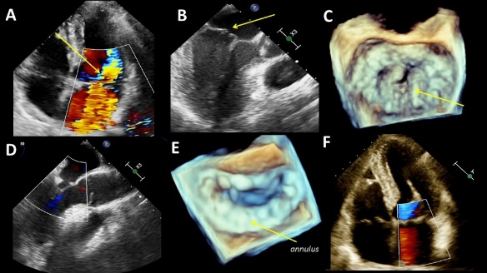
Left ventricular outflow tract obstruction due to SAM is not always hypertrophic cardiomyopathy. \”Sigmoid septum\” as a cause of recurrent syncope in 78-year-old patient – a case report
Authors: Natalia Jurzak-Myśliwy, Wojciech Kula, Sergiusz Nowak, Bożena Janicka-Korszla, Grzegorz Sobieszek
Medical University of Lublin, Lublin, Poland

A 78-year-old patient with history of hypertension and Parkinson\'s disease was admitted to the Cardiology Department, for the diagnosis of recurrent syncope. No significant abnormalities were found in the imaging of central nervous system and electroencephalography (EEG). In transthoracic echocardiography (TTE) thickening of the basal segment of the ventricular septum up to 14 mm was observed. In the Valsalva maneuver, systolic anterior motion (SAM) was generated, causing left ventricular outflow tract obstruction. The biggest challenge was the assessment of the peak pressure gradient in LVOTO. It was considered that the peak gradient value of 160mmHg in one of the measurements most likely was in fact the spectrum of being formed mitral regurgitation (despite the dagger-shapd so characteristic for obstruction). It was determined that the actual peak pressure gradient was 55 mmHg. Due to the suboptimal visualization in the TTE, transesophageal echocardiography was performed, confirming the initial diagnosis. After starting b-blocker treatment, discontinuation of diuretics and proper hydration, no recurrences of syncope were observed and the maximum provoked peak pressure gradient was 22 mmHg. The interruption in the treatment with b-blocker resulted in the recurrence of the problem. There have been no adverse events in the 18-month follow-up during b-blocker treatment and proper hydration.

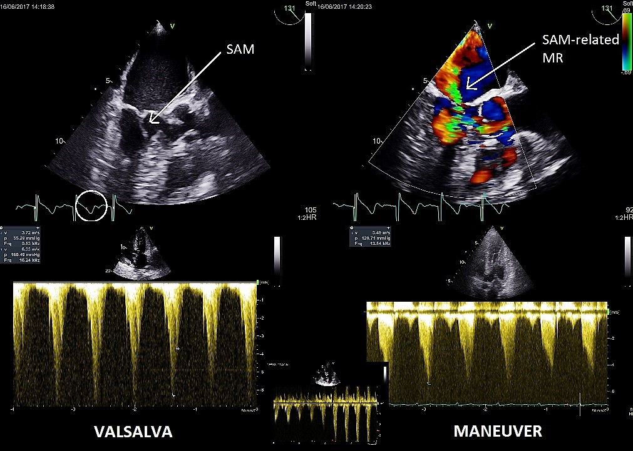

Coronary fistula in apical part of LV as a rare cause of stenocardia – case report
Authors: Piotr Hamala, Jarosław Kasprzak, Jan Zbigniew Peruga, Konrad Szymczyk, Karina Wierzbowska-Drabik
Medical University of Lodz, Lodz, Poland

We report 63-year-old female admitted to Cardiology Department due to recurrent, exercise-related angina. Medical history revealed arterial hypertension, diabetes, hypercholesterolemia, obesity without previous data for coronary artery disease. Other coronary risk factors such as: smoking, family history of CAD were negative. Laboratory examinations showed: total cholesterol 108 mg/dl [130-200], cholesterol LDL 41,6 mg/dl [45-130], NT-Pro BNP 157.6 pg/ml [0-125 pg/ml], normal troponin level. There wasn’t significant abnormalities in physical examination and in resting ECG. Treadmill exercise test revealed ventricular extrasystoles associated with exercise and was interrupted because of fatigue at 4.6 METs, before achieving of age-predicted heart limit without recording of ST segment abnormalities.
Single-photon emission tomography showed exercise induced, reversible perfusion defect in the antero-lateral wall including 10% of myocardium.
Echocardiography reveal good left ventricular (LV) contractility with EF of 58%, but during color Doppler examination untypical turbulent diastolic flow was observed in apical lateral segment indicating the blood leak into LV chamber, see Figure panels: 1 and 2.
Coronary angiography revealed fistulas connecting second diagonal branch with LV chamber in the apical region. (see Figure, panel 3). Then, 64 multislice CT with contrast was performed showing the group of thin vessels crossing through cardiac wall and forming connection between coronary artery and left ventricle in apical lateral part of LV (see Figure panel 4). The segments of coronary artery where the fistulae were originated corresponded to the reversible perfusion defects in SPECT, confirming the flow significance through them. The pathophysiologic explanation of ischemia lies in coronary stealing phenomenon (reduction of blood flow through artery, distal to the fistulae). After discontinuation of nitrate therapy and continuation of bisoprolol, ramipril and atorvastatin symptoms of angina diminished from third to first CCS class and exercise tolerance had been significantly improved.
Discussion:
Coronary – ventricle fistulae are observed in 0-2% of coronary angiographies. Some studies suggest connection with myocardial hypertrophy, especially apical hypertrophy. Embryology studies suggest a pathological complication in Thebesian vein system (the smallest vein in human heart) development. According to pathophysiology, symptoms of coronary ischemia are revealed during nitrate therapy because of leakage increase. Abubakar H et all documented symptoms worsening directly after intravenous nitrate infusion in patient admitted to cardiac acute care unit.
Proposed treatment in the literature include: surgical ligation, percutaneous intervention, pharmacology (betablocers, ranolazine). As it was mentioned previously nitrate therapy is not recommended since it may exacerbate the symptoms. Ivabradine can be considered when contraindication to betablockers exists.
Similarly, in our patient intervention based on excluding nitrates result in significant symptoms alleviation. Patient was consulted with cardiac surgeon and interventional cardiologist. According to satisfactory pharmacology effect patient was not submitted to any interventional treatment.

Hypereosinophilic Syndrome Presenting with Large Left Ventricular Apical Thrombus
Authors: Tomasz Grycewicz, Karolina Szymańska, Agnieszka Dębska-Kozłowska, Andrzej Lubiński
Medical University of Lodz, Lodz, Poland

Hypereosinophilic syndrome (HES) is a rare disorder characterized by high eosinophilic count without any evidence for other known causes of eosinophilia. Cardiac involvement may be present in more than 50% of the patients. We report a case of a 63-year-old man presenting with chest pain and signs and symptoms of heart failure. Laboratory studies at admission showed leukocytosis and eosinophilia. Transthoracic echocardiography showed large thrombus obliterating the left ventricle (Fig. 1). The extent of thrombus was confirmed in magnetic resonance examination. Corticosteroids were administered, which resulted in improvement in peripheral eosinophilia with improved clinical status, despite only minor decrease of left ventricle thrombus volume during first weeks of treatment.

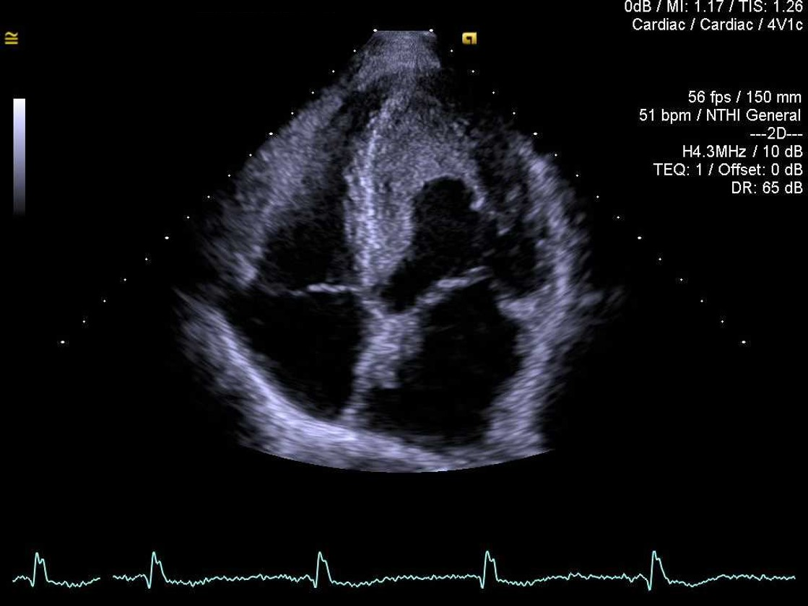

Tricuspid Valve Endocarditis with a Large Vegetation
Authors: Tomasz Grycewicz, Agnieszka Dębska-Kozłowska, Emilia Borowik, Włodzimierz Grabowicz, Karolina Szymańska, Andrzej Lubiński
Medical University of Lodz, Lodz, Poland

Tricuspid valve endocarditis accounts for 5 - 10% of all cases of infective endocarditis and most commonly occurs in intravenous drug users. We present a case of infective endocarditis with very large vegetations on tricuspid valve in patient with history of intravenous drug abuse. The 30 years old patient presented with fever and dyspnoea. On echocardiographic examination large vegetations located on all three tricuspid leaflets comprising partially papillary muscles were detected (Fig. 1). Blood cultures revealed Staphylococcus aureus infection. Unfortunately, due to rapid progression of the disease, patient died before surgical intervention, despite intensive antimicrobial therapy.

